Nike Azure Days

Azure Infrastructure Orchestration and Automation

Windows Workshop Guide

January 24th, 2018

© 2018 Microsoft Corporation. All rights reserved. This document is confidential and proprietary to Microsoft. Internal use only. This document is for informational purposes only. MICROSOFT MAKES NO WARRANTIES, EXPRESS OR IMPLIED, IN THIS SUMMARY.

This document is provided "as-is." Information and views expressed in this document, including URL and other Internet Web site references, may change without notice. You bear the risk of using it.

Some examples are for illustration only and are fictitious. No real association is intended or inferred.

# Azure Infrastructure and Automation - Windows Workshop Guide

## Overview

This workshop guide is intended to walk you through the automated deployment of a Windows Server 2016 environment running an IIS website. We will be using Powershell, Azure Resource Manager (ARM) templates, and Powershell DSC to deploy and configure the environment. We will also look at then packaging the deployed app environment as a Docker image, pushing the image to an Azure Container Registry, and then deploying the image as an Azure Container Instance.

## What You Will Build

A simple application deployment on IaaS infrastructure consisting of:

Virtual Networks

Load Balancer

Operations Management Suite

Azure Automation

KeyVault

Virtual Machines

DSC configuration for IIS

Windows containers using Dockerfile

## Requirements

* Powershell ISE
* Git Bash
* Code Editor (Visual Studio Code recommended)
* Text Editor (such as notepad or textedit)
* Azure Powershell SDK cmdlets
* Azure Subscription with Owner role (provided for workshop)

## Help References

|  |  |
| --- | --- |
| Powershell ISE overview | https://docs.microsoft.com/en-us/powershell/scripting/core-powershell/ise/introducing-the-windows-powershell-ise?view=powershell-5.1 |
| Git Installation | https://git-scm.com/book/en/v2/Getting-Started-Installing-Git |
| Visual Studio Code | https://code.visualstudio.com/ |
| Azure Powershell installation | https://docs.microsoft.com/en-us/powershell/azure/install-azurerm-ps |

# Step 1 – Clone GitHub Repository and Open Notepad/TextEdit

## Overview

The first step involves cloning a Github repository that includes the scripts and configuration files that will be used in this workshop.

## Detailed Steps

1. Open Git Bash, change to a directory in which you’d like to create the new repo directory to clone into

mkdir <directory name>

1. Change the working directory to your newly created one and then clone the repository from Github.

cd <directory name>

git clone https://github.com/lorax79/AzureDays

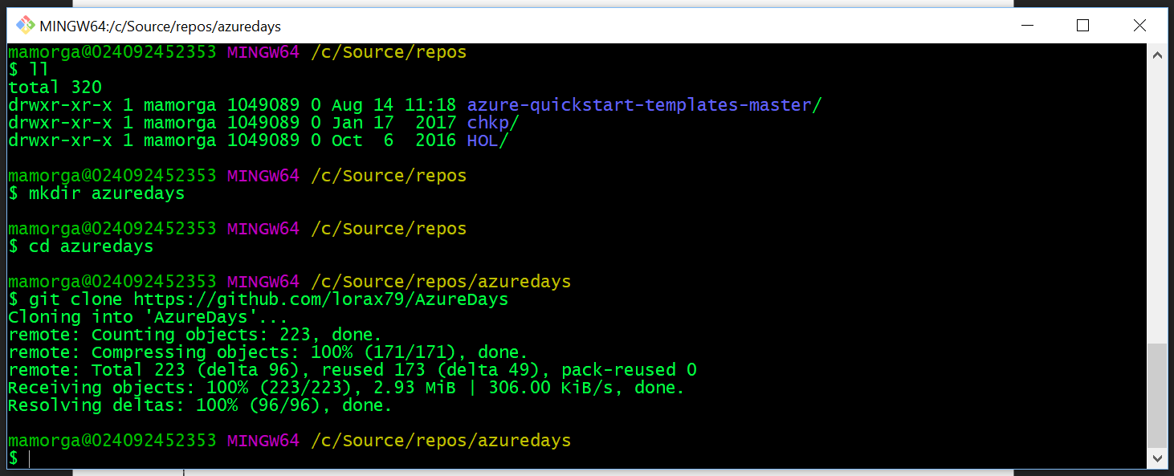

1. Open Notepad, TextEdit or another tool to keep track of IDs, names, and other items you use in various steps of the workshop.

# Step 2 – Open files in PS ISE & VS Code

## Overview

This step involves opening the directory we just cloned from github in Visual Studio Code.

## Detailed Steps

1. Open Visual Studio Code
2. CTRL + P will expose command window, type “ext install” ENTER to show available extensions.
3. Search for “azure resource manager” and install “Azure Resource Manager” tools (optional but useful for working with templates)

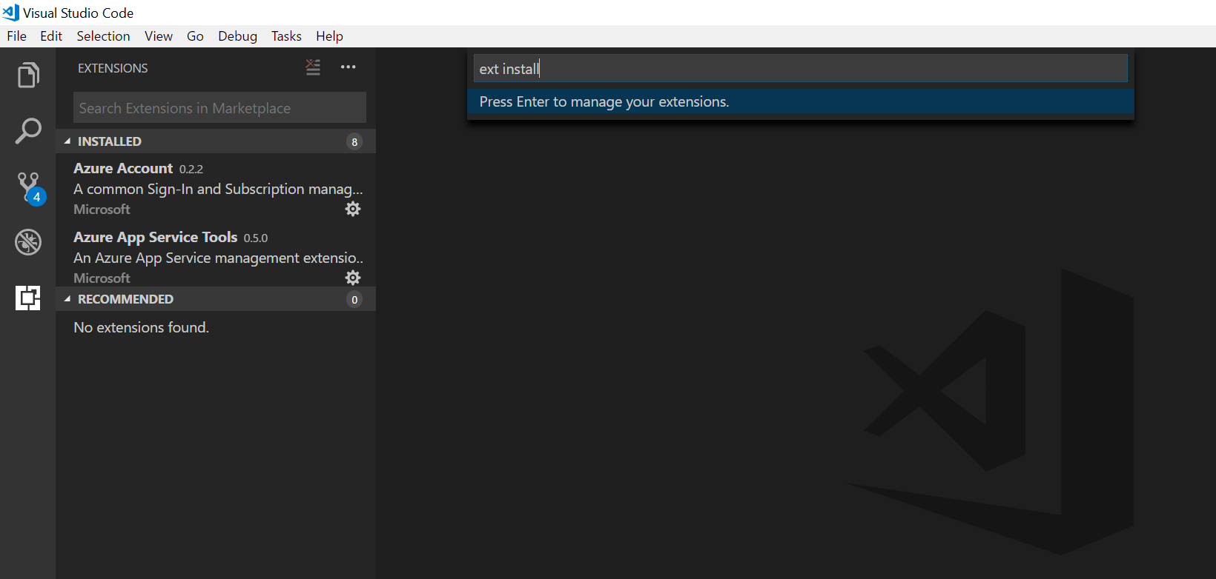

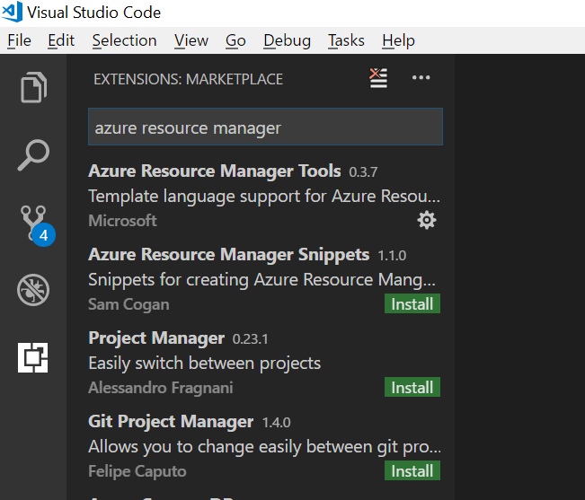

1. Select the Explorer icon and then “Open Folder”, browse to repo directory you just created and open.

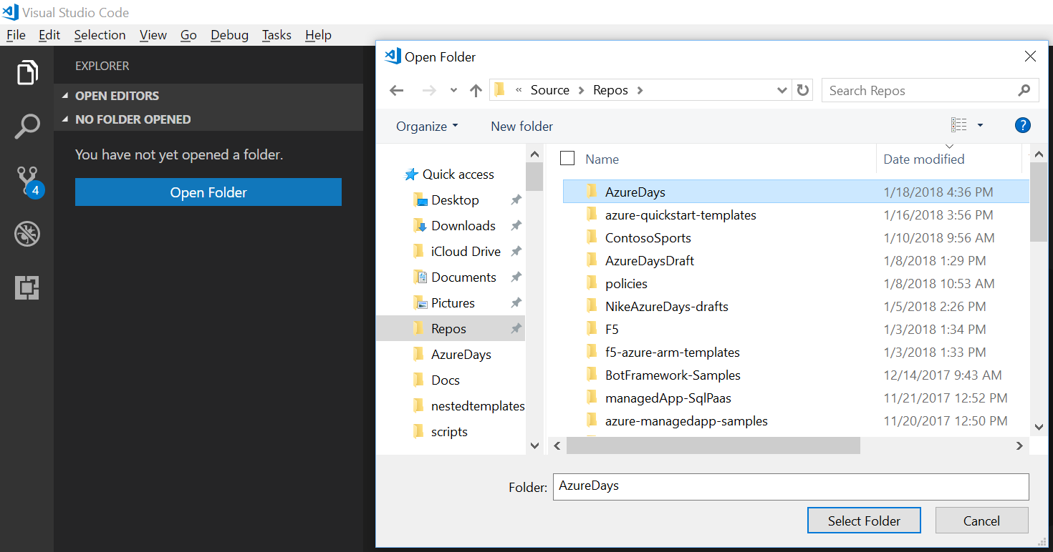

1. If you click the explorer icon in Visual Studio Code, you should see the contents of the directory.

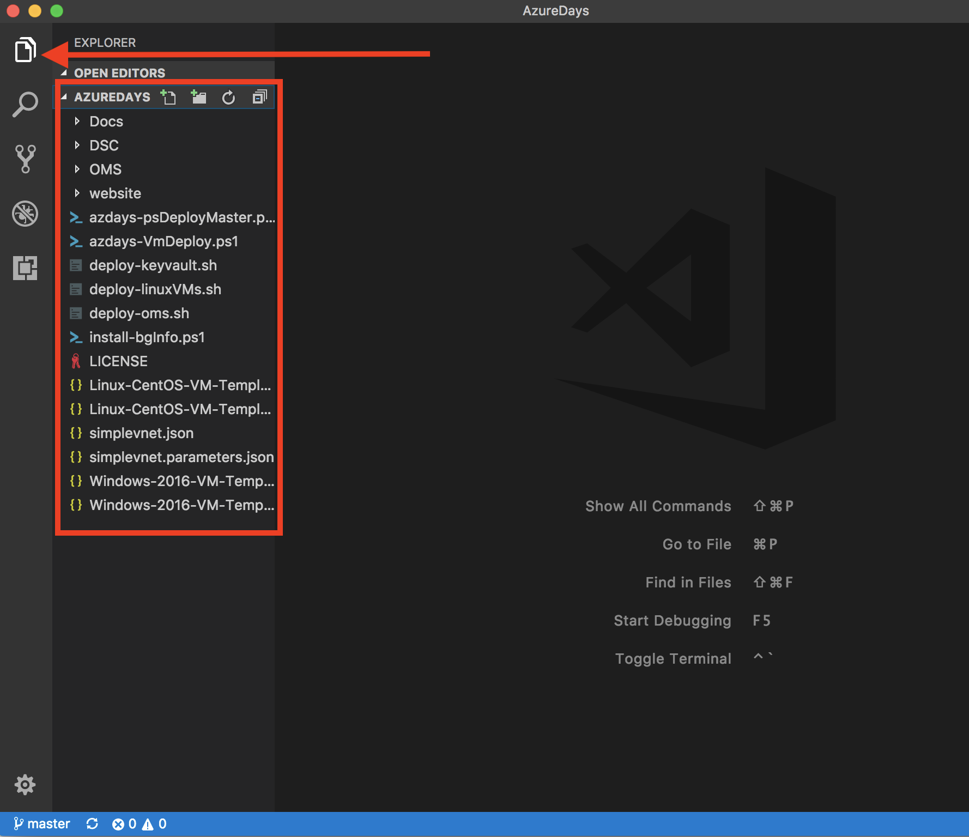

1. Open Powershell ISE, browse to your code directory and open the 3 - .ps1 files:   
   azdays-psDeployMaster, azdays-VmDeploy, and /DSC/WebConfig.
   1. azdays-psDeployMaster is a full step-by-step walkthrough of all the workshop steps. It is intended to expose you many of the cmdlets, objects, and patterns you can use with Powershell in Azure. Don’t just run the whole script end to end, you can select sections and run with F8 or the small ‘play’ button

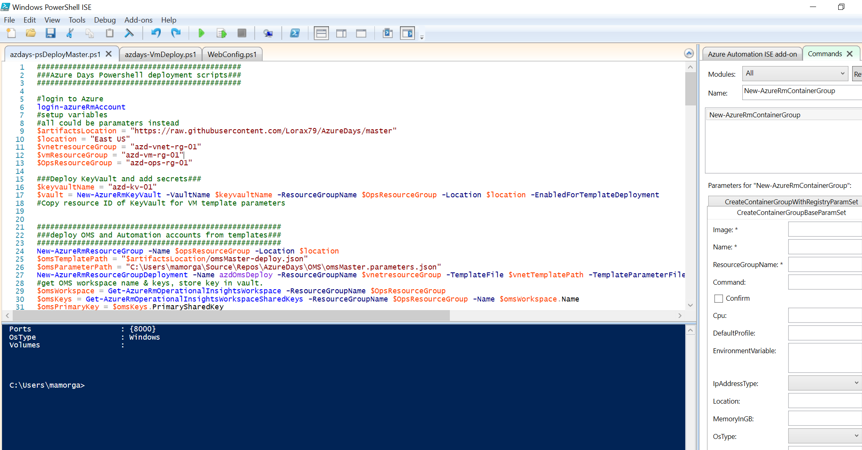

b. azdays-VmDeploy is intended to be run completely as a script/runbook with parameters when we get to the VM deployment steps.

# Step 3 – Login to your subscription via Powershell ISE

## Overview

This workshop involves deploying ARM templates and running scripts using Powershell. The Powershell ISE is a free extensible scripting environment included with Windows we will be using. Running Azure Resource Manager commands requires the Azure Powershell modules to be installed from <https://docs.microsoft.com/en-us/powershell/azure/install-azurerm-ps> if you haven’t already.

## Detailed Steps

1. In the ISE Command pane, type login-azureRmAccount
2. Login with the credentials for your Azure subscription.

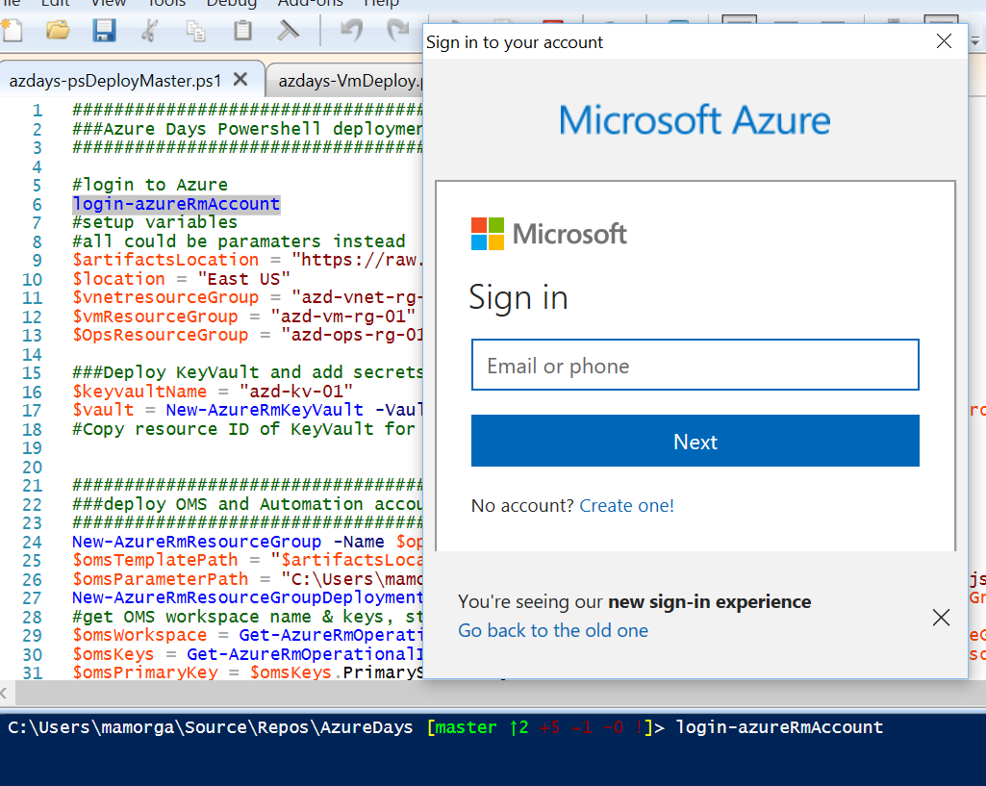

1. After login you will see your account, subscription, and tenant info. While we’re not using any of this info for the Windows automation it’s a good idea to copy it to a notepad.

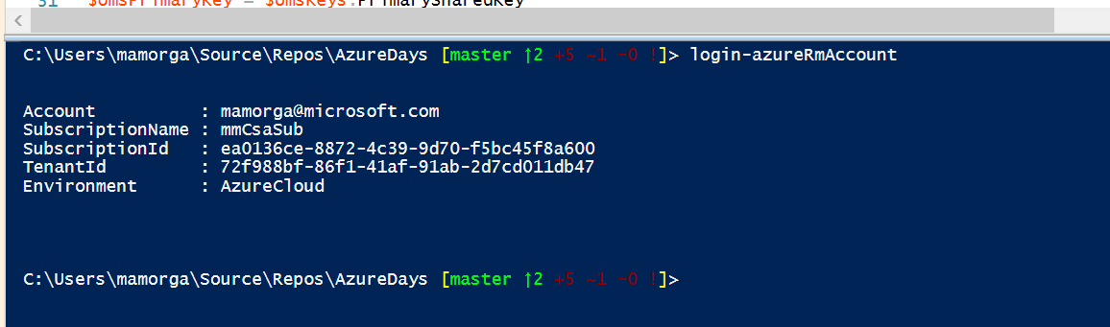

# Step 4 – Set variables and parameters for Operations Management Suite Deployment from ARM templates.

## Overview

In this step you will edit an ARM template parameters file for deployment. You will be setting values that will be used in the creation of an OMS workspace, automation account, and recovery vault. These files will be edited with Visual Studio Code. The template will be deployed with a Powershell command.

## Detailed Steps

1. Open the OMS/omsMaster.paramaters.json file in Visual Studio Code and specify the empty parameters as seen in the screenshot below. Make the resource name parameters for the RecoveryVault and OMS Workspace as unique as possible, e.g. “jorsmith-nikeoms1223”. For the Windows deployments, please enter an admin username in ‘User@domain.com’ format. It doesn’t have to be a real UPN, but we will be creating a credential variable that assumes a ‘real-world’ UPN format later. The password can be anything reasonably long/secure, please take note or remember it.
2. Save the .parameters file when complete, copy the local file location to notepad.

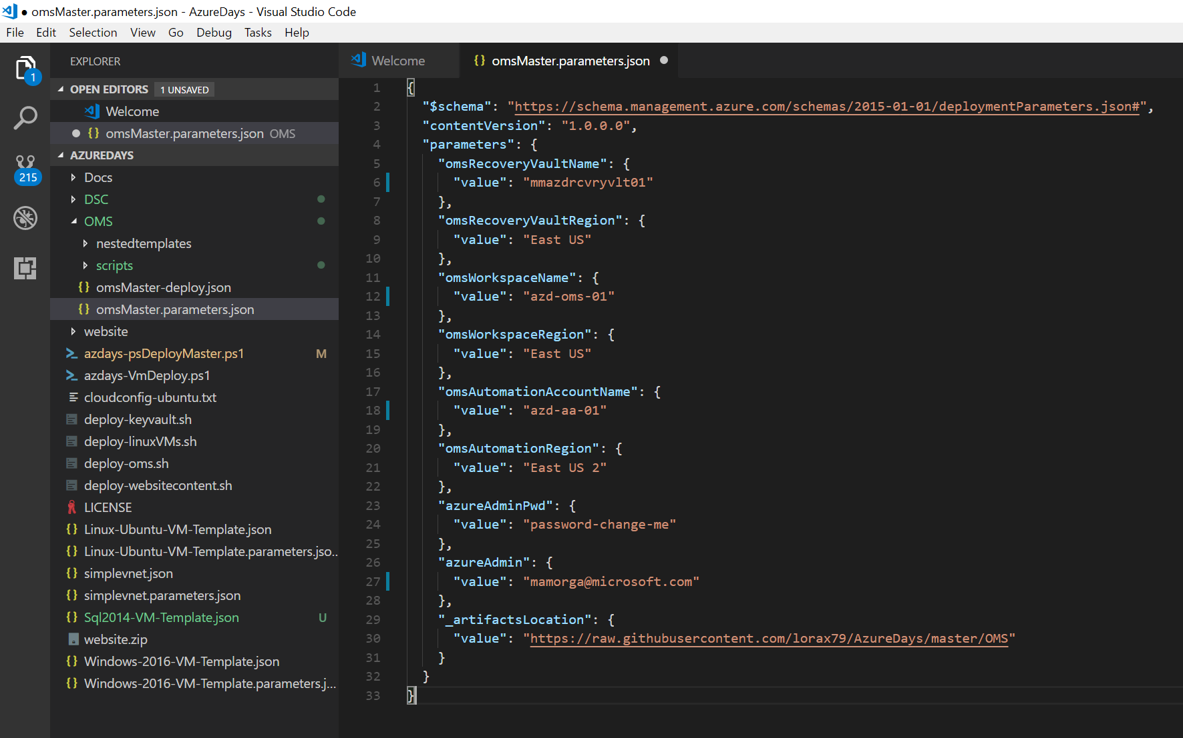

1. Either by selecting and running with F8 or typing in a new script pane tab, setup variables for the OMS deployment. Change the $OpsResourceGroup variable to whatever name you’d like for the Operations Resource Group.

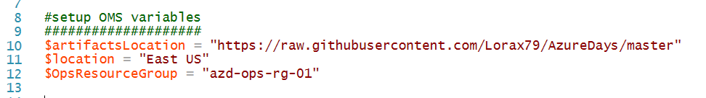

# Step 5 – Deploy OMS Workspace and View Deployment in Portal

## Overview

In this step you begin deploying resources. You will create a new Resource Group which will contain the OMS and Automation resources – Log Analytics Workspace, Automation Account, and Recovery Vault. You will then deploy from ARM template with the parameters just saved using Powershell.

## Detailed Steps

1. Create a new Resource Group with the $OpsResourceGroup variable as name:

New-AzureRmResourceGroup -Name $opsResourceGroup -Location $location

You should get output showing new Resource Group info  
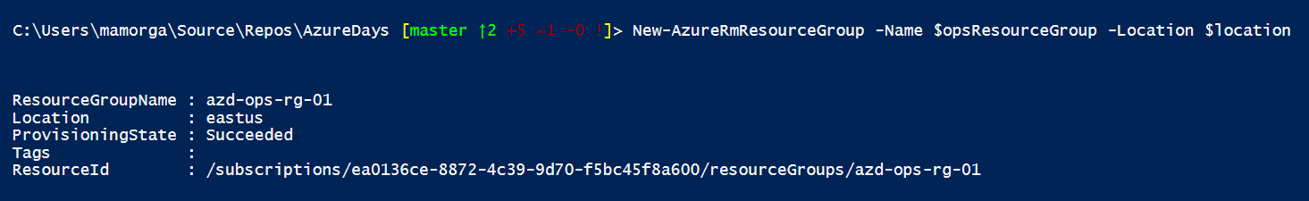

Deploy the ARM template by running the following code, changing the value of $omsParameterPath. Note that the parameters have been splatted onto separate lines using the ` escape character for ease of reading.   
  
New-AzureRmResourceGroup -Name $opsResourceGroup -Location $location

$omsTemplatePath = "$artifactsLocation/OMS/omsMaster-deploy.json"

$omsParameterPath = "C:\Users\mamorga\Source\Repos\AzureDays\OMS\omsMaster.parameters.json"

New-AzureRmResourceGroupDeployment `

-Name azdOmsDeploy `

-ResourceGroupName $opsResourceGroup `

-TemplateFile $omsTemplatePath `

-TemplateParameterFile $omsParameterPath `

-Mode Incremental `

-Verbose

1. The deployment will start. If you receive errors read them and adjust your parameters file accordingly. While the deployment runs you will see operations output.  
   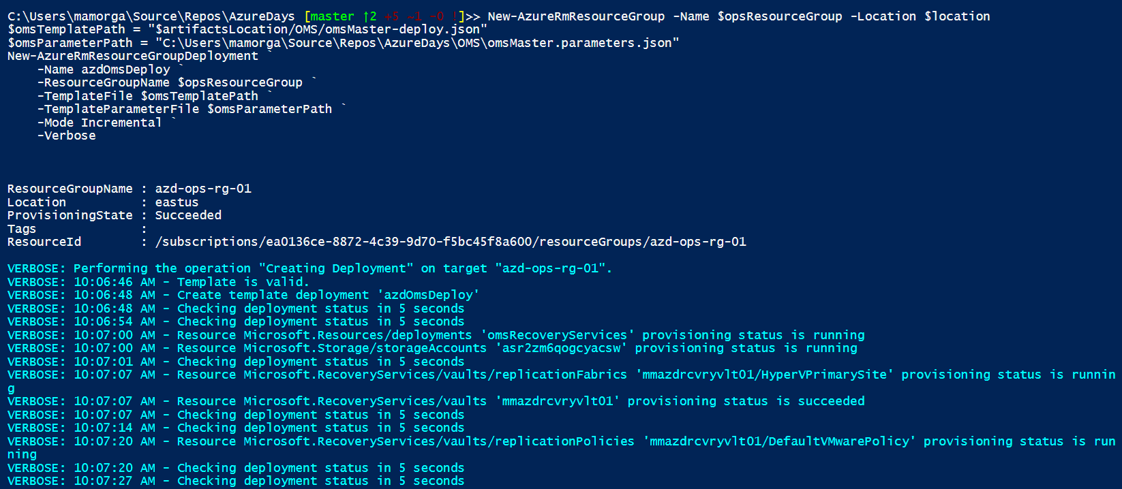
2. The deployment will run for somewhere around 10 minutes. While it runs take a look at the deployment events from the portal. Login to <https://portal.azure.com> and browse to Resource Groups.

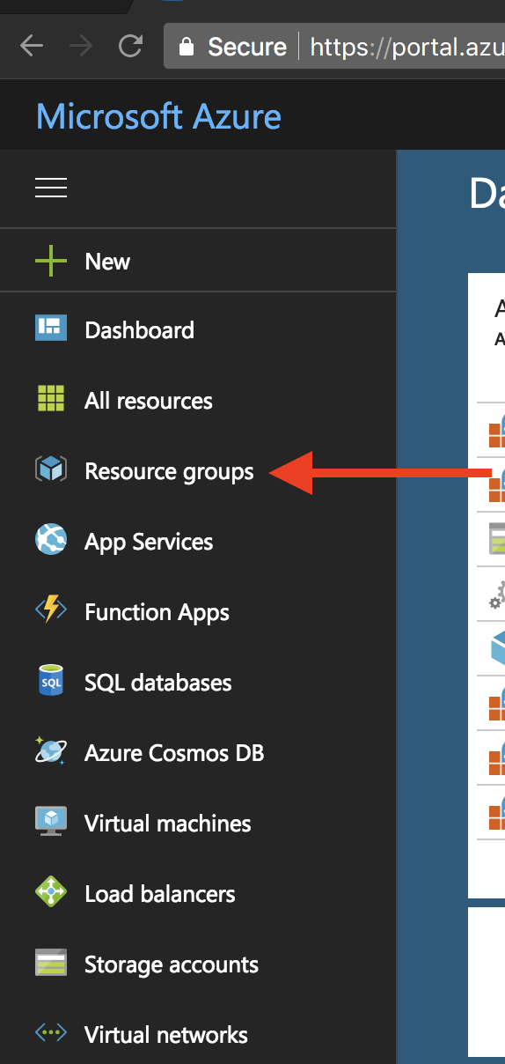

1. Now click on the resource group you created above. Then click on “Deployments”. Here you will see the deployments that are running as a result of the script we ran. Clicking on the deployments will show you the operations that are running and what resources the ARM template is deploying. Clicking through to ‘Events’ from each deployment will show API events & error details.

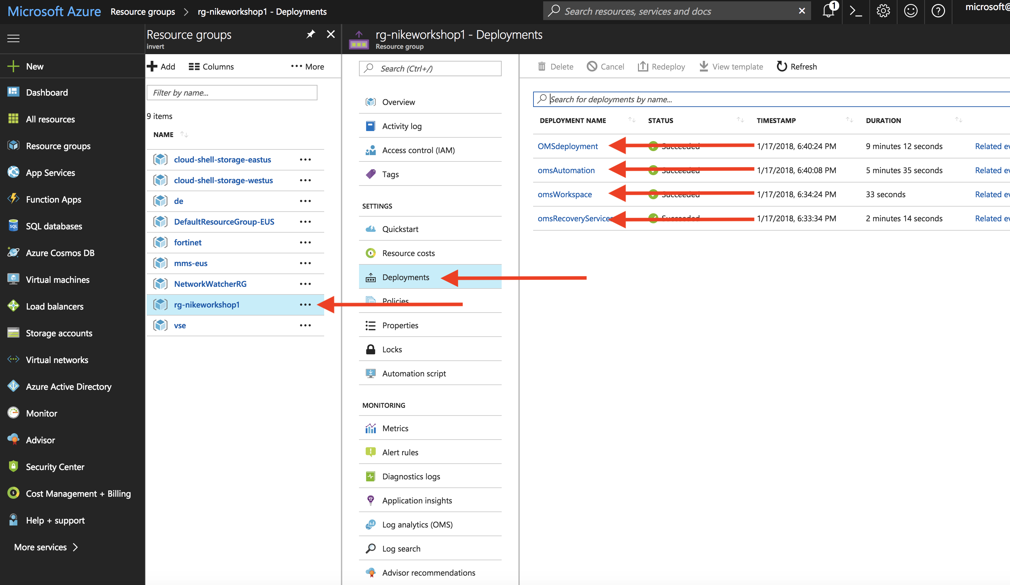

1. When the deployment completes you’ll see output like below in the ISE command pane.

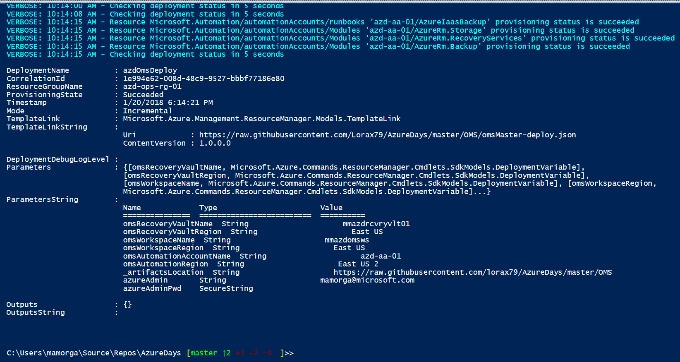

# Step 6 – Deploy KeyVault

## Overview

KeyVault is an Azure service that allows you to store passwords, secrets, and cryptograpics keys in a secure manner. In this step you will be deploying KeyVault and storing the OMS Workspace key as well as admin credentials for your VM deployments.

## Detailed Steps

1. Set the $keyvaultName variable with the KeyVault name you want to use. Deploy the KeyVault by running:

$keyvaultName = "azd-kv-01"

$vault = New-AzureRmKeyVault `

-VaultName $keyvaultName `

-ResourceGroupName $OpsResourceGroup `

-Location $location `

-EnabledForTemplateDeployment

1. When the deployment completes in a couple of minutes, type ‘$vault’ at the command pane prompt to return the KeyVault object properties.

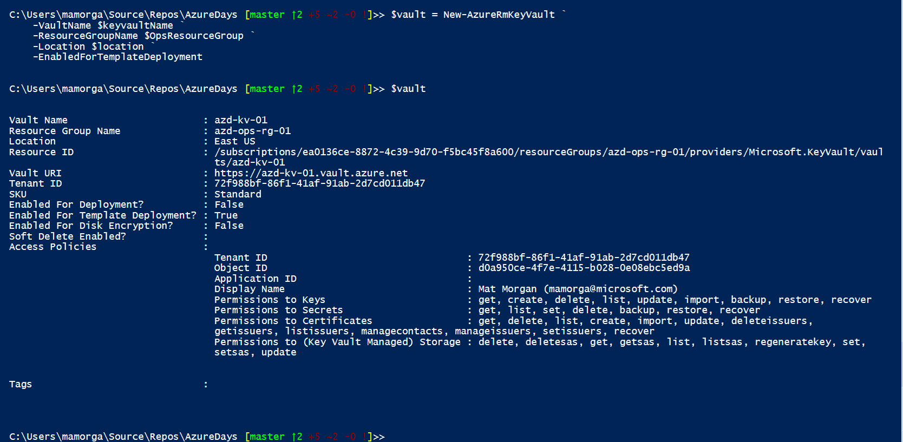

1. Now that the KeyVault exists, we can retrieve the key for the OMS workspace and save it to the vault by running the following. After running type “$opsVault” to see secret object.   
   $omsWorkspace = Get-AzureRmOperationalInsightsWorkspace -ResourceGroupName $OpsResourceGroup

$omsKeys = Get-AzureRmOperationalInsightsWorkspaceSharedKeys -ResourceGroupName $OpsResourceGroup -Name $omsWorkspace.Name

$omsPrimaryKey = $omsKeys.PrimarySharedKey

$omsSecret = ConvertTo-SecureString $omsPrimaryKey -AsPlainText -force

$omsVault = Set-AzureKeyVaultSecret -VaultName $keyvaultName -Name 'omsKey' -SecretValue $omsSecret

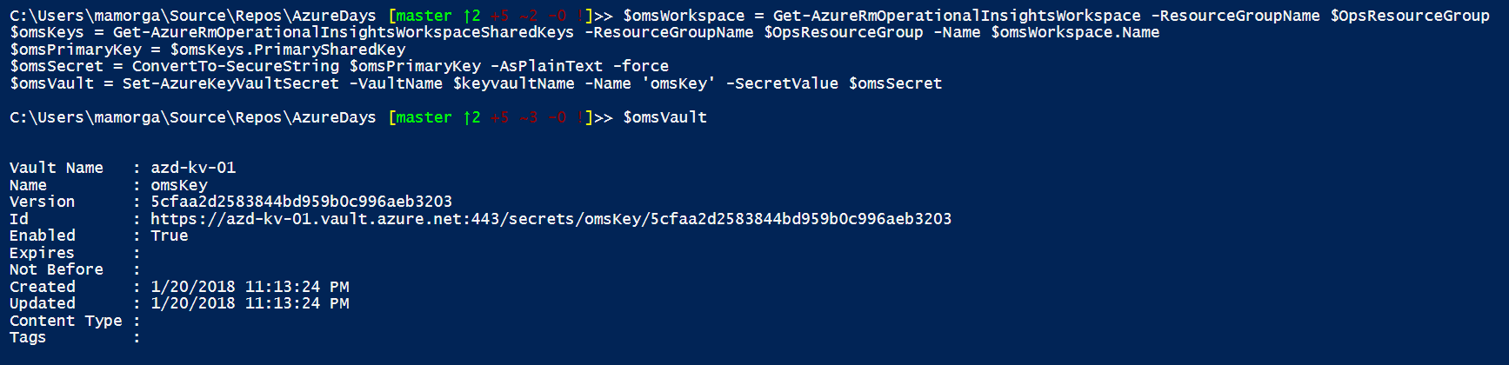

1. The next credential secret we will setup is an admin account for VM access. As we previously stored an ‘AzureAdmin’ credential when setting up the OMS parameters, we will use that admin username (substring before the ‘@’) and prompt for a password to store securely. The VM admin password will then be stored to KeyVault.  
   $Account = Get-AzureRmAutomationAccount -ResourceGroupName $OpsResourceGroup

$autoAccountName = $account.AutomationAccountName

$adminCredential = Get-AzureRmAutomationCredential -ResourceGroupName $OpsResourceGroup -AutomationAccountName $autoAccountName -Name AzureCredentials

$adminUsername = $adminCredential.UserName

$adminCredential = Get-Credential -UserName $adminUsername -Message "Please enter the password for the Azure Admin user for the VM"

$adminPassword = $adminCredential.Password

#store Admin credentials in Keyvault

$secret = Set-AzureKeyVaultSecret -VaultName $keyvaultName -Name 'vmAdminPassword' -SecretValue $adminPassword

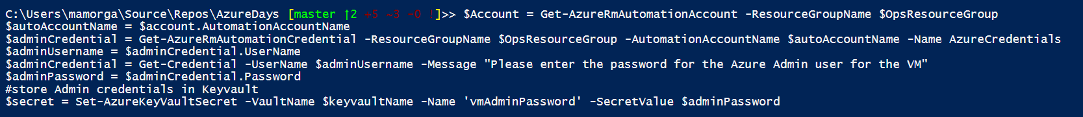

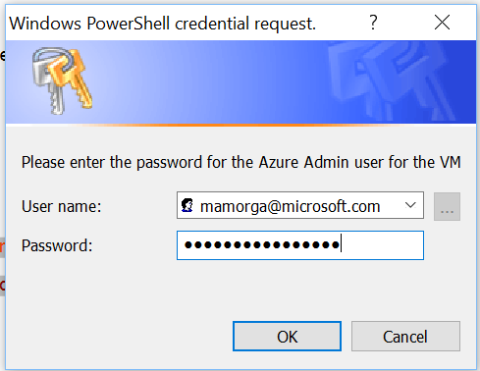

1. The final sets of variables and keys we will setup are for VM registration to the Automation DSC service, Storage account keys for the storage located in the Ops resource group and deployment variables for the VNETs.   
   First pull the registration info from the Automation Account:  
   $RegistrationInfo = $Account | Get-AzureRmAutomationRegistrationInfo

$registrationUrl = $RegistrationInfo.Endpoint

$registrationKey = $RegistrationInfo.PrimaryKey   
  
Next pull the Keys from the Storage Account:  
$storageAccount = Get-AzureRmStorageAccount -ResourceGroupName $opsResourceGroup

$storageAccountKeys = Get-AzureRmStorageAccountKey -ResourceGroupName $OpsResourceGroup -Name $storageAccount.StorageAccountName

$storagePrimaryKey = $storageAccountKeys[0].value

Then write all the variables, note that the Key variables are set as encrypted:

$opsRgVar = New-AzureRmAutomationVariable -Encrypted $false -Name "OpsResourceGroup" -ResourceGroupName $OpsResourceGroup -AutomationAccountName $autoAccountName -Value $OpsresourceGroup

$vnetRgVar = New-AzureRmAutomationVariable -Encrypted $false -Name "VnetResourceGroup" -ResourceGroupName $OpsResourceGroup -AutomationAccountName $autoAccountName -Value $vnetresourceGroup

$artifactsVar = New-AzureRmAutomationVariable -Encrypted $false -Name "artifactsLocation" -ResourceGroupName $OpsResourceGroup -AutomationAccountName $autoAccountName -Value $artifactsLocation

$storageAccountNameVar = New-AzureRmAutomationVariable -Encrypted $false -Name "saname" -ResourceGroupName $OpsResourceGroup -AutomationAccountName $autoAccountName -Value $storageAccount.StorageAccountName

$storageAccountKeyVar = New-AzureRmAutomationVariable -Encrypted $true -Name "sakey" -ResourceGroupName $OpsResourceGroup -AutomationAccountName $autoAccountName -Value $storagePrimaryKey

# Step 7 – Prepare DSC configuration and files for Website deployment

## Overview

We will be copying website content from the Git repo into our Azure Storage account. We will then be uploading and compiling a DSC (Desired State Configuration) template into the Automation account DSC service to make it available as a VM node config.

## Detailed Steps

1. We will set a storage context using the account name & key we pulled earlier, then create a new blob container named “website-bits”.   
   $Context = New-AzureStorageContext -StorageAccountName $storageAccount.StorageAccountName -StorageAccountKey $storagePrimaryKey

$container = New-AzureStorageContainer -Name "website-bits" -Context $Context

1. Next start a Storage blob copy job from the GIT repo URI to the new storage container with a destination name of ‘azdays-website.zip’. You should see the file output shown below.   
   Start-AzureStorageBlobCopy -AbsoluteUri "$artifactsLocation/website.zip" -DestContainer $container.Name -DestBlob "azdays-website.zip" -DestContext $Context

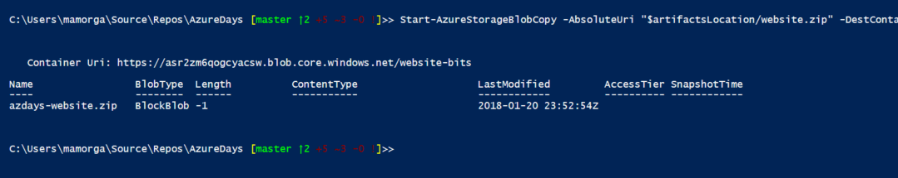

1. Now open the ‘webConfig.ps1’ file in Powershell ISE. This is the DSC config we will be using to configure our Web VMs after deployment. It does the following:  
     
   Declares a config name (Webconfig) and imports modules it needs, sets variables for local directories and storage account access  
   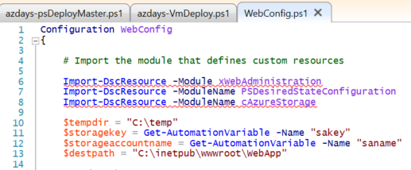  
     
   Declares a single Node name (‘Web’, which means machines using this config will have a nodeConfiguration name setting of ‘WebConfig.Web’), then installs .NET 4.5 and IIS Features needed.   
   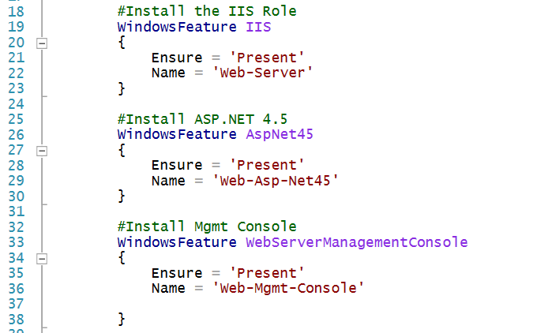

Finally, the config takes the steps needed to setup the website: Stops the default IIS site, checks for tempdir, copies the content from Storage to tempdir, Unzips the content into the IIS webroot, and creates the new site.   
  
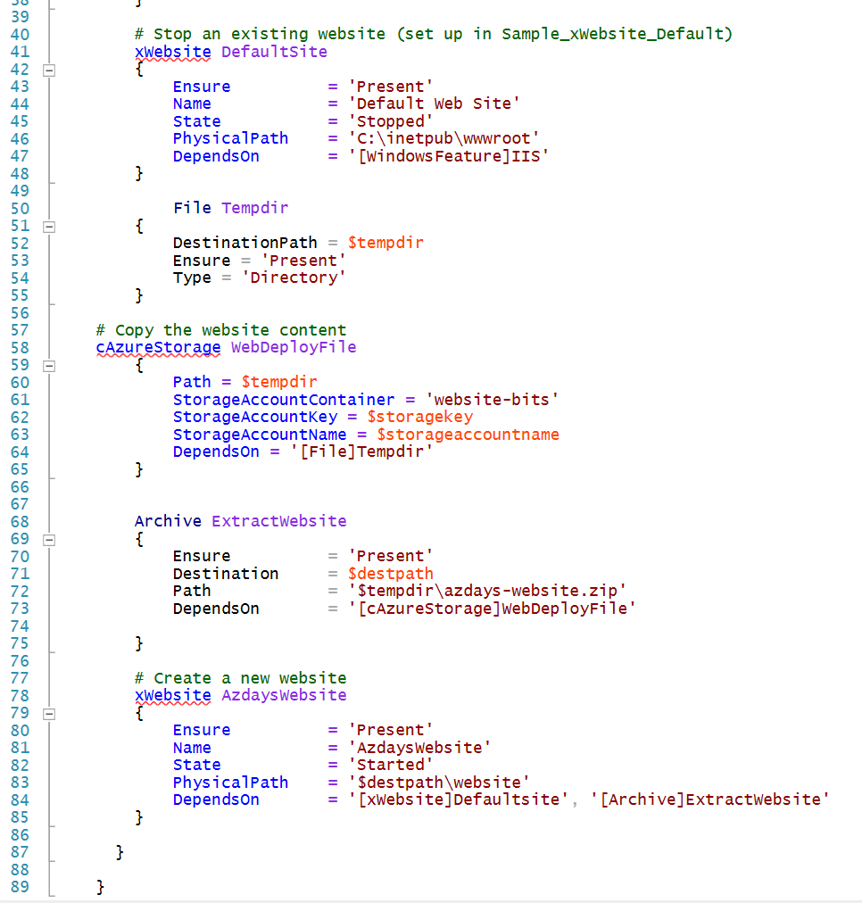

1. To upload and compile the configuration, browse to the Automation account in the Azure portal and locate ‘<your-ops-resourceGroup> -> <your Automation Account> -> DSC Configurations’.

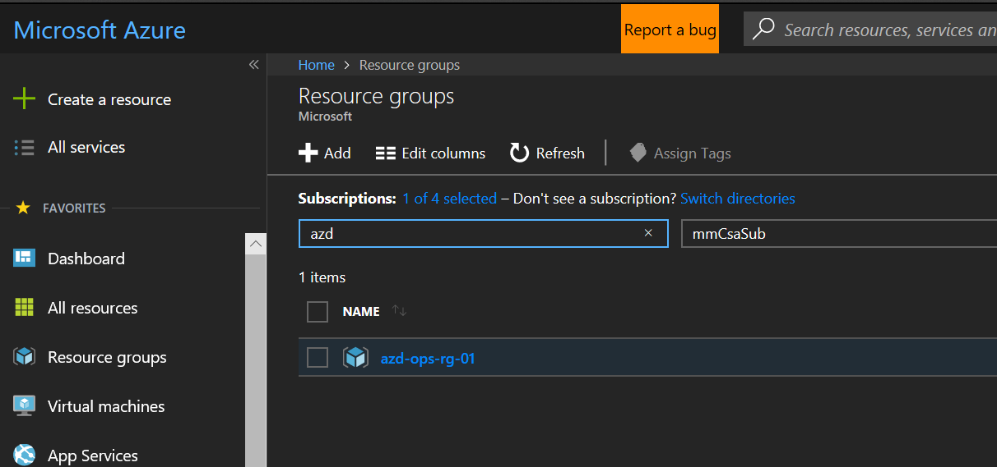  
  
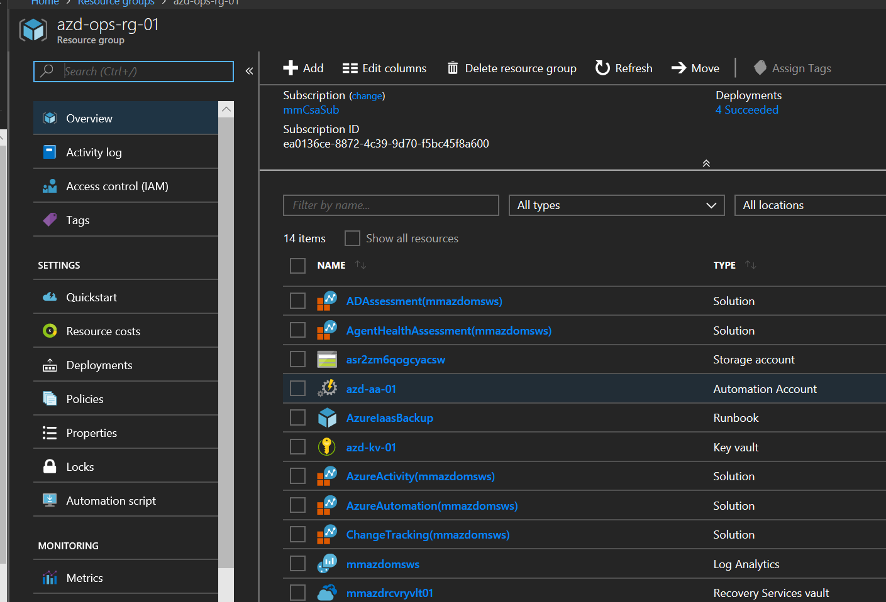

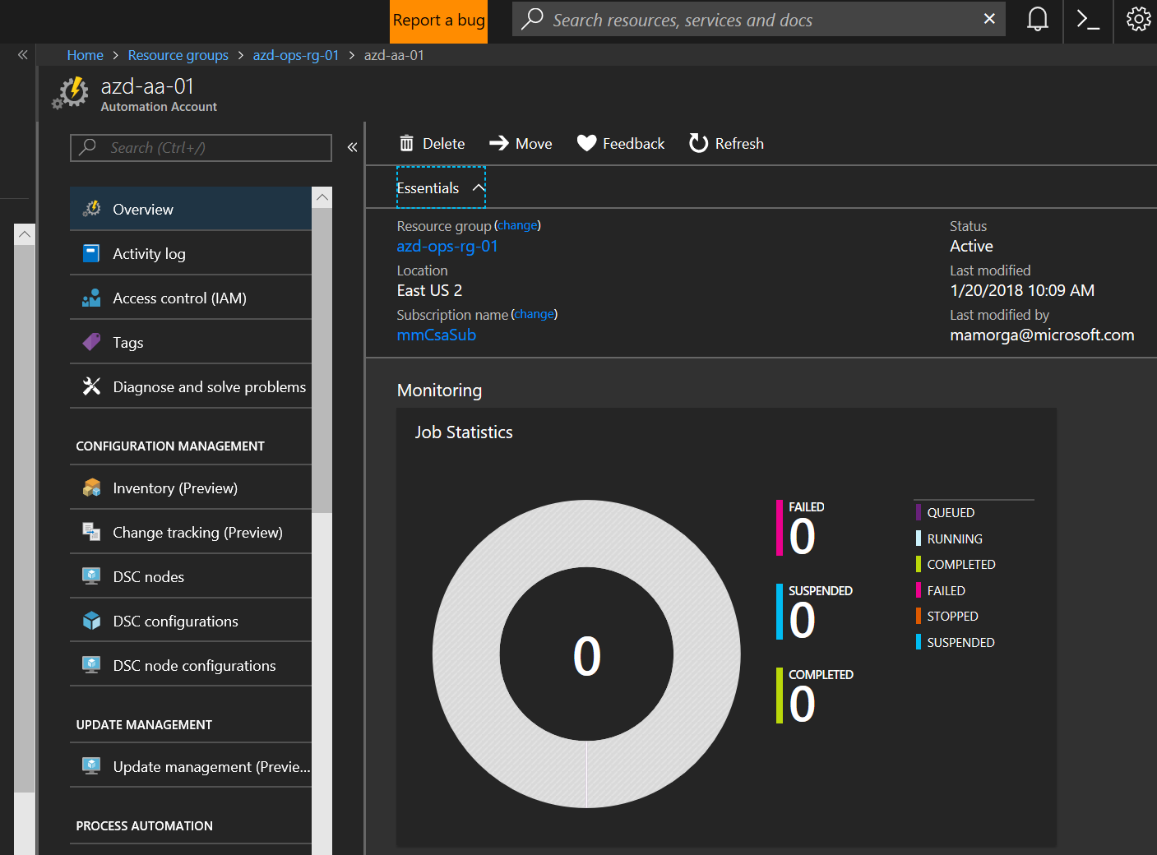

1. Select ‘Add a Configuration’, browse to the ‘WebConfig.ps1’ file and name it ‘WebConfig’ (default). Click OK.

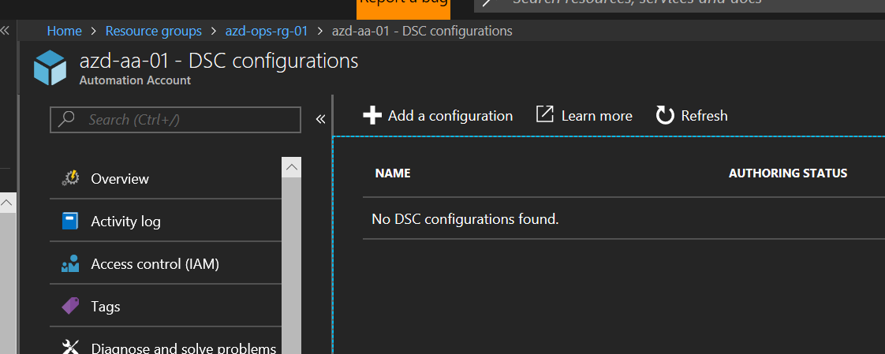  
  
  
  
  
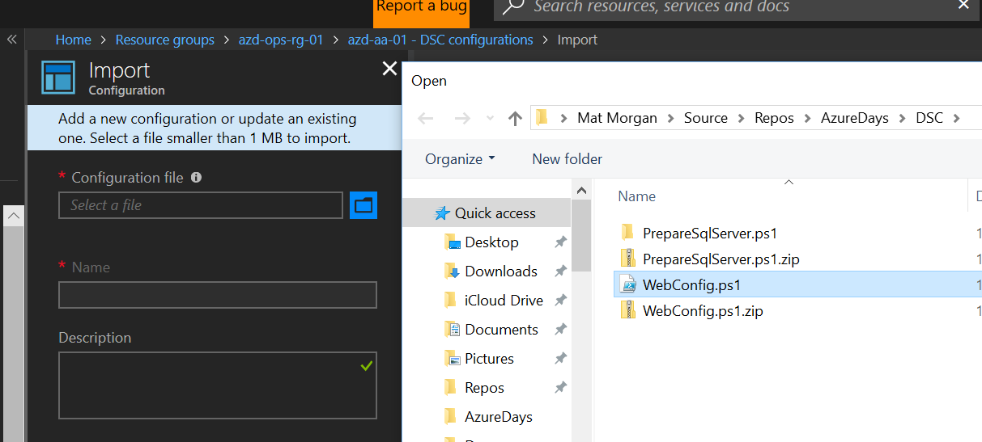

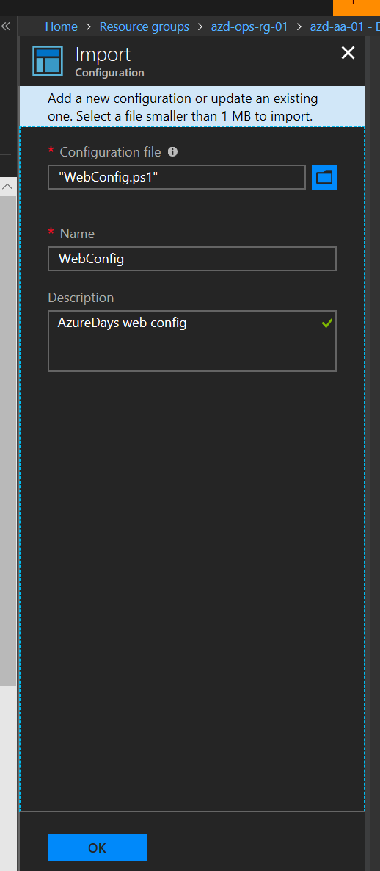

1. After config file is uploaded, select it and then click ‘Compile’. Click ‘Yes’ when asked to confirm. The compilation job should run for a few minutes & then show ‘Completed’ when done.

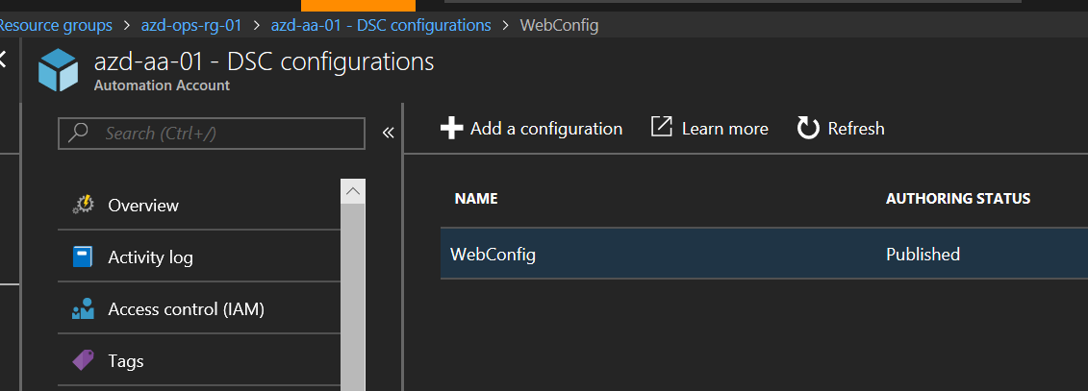  
  
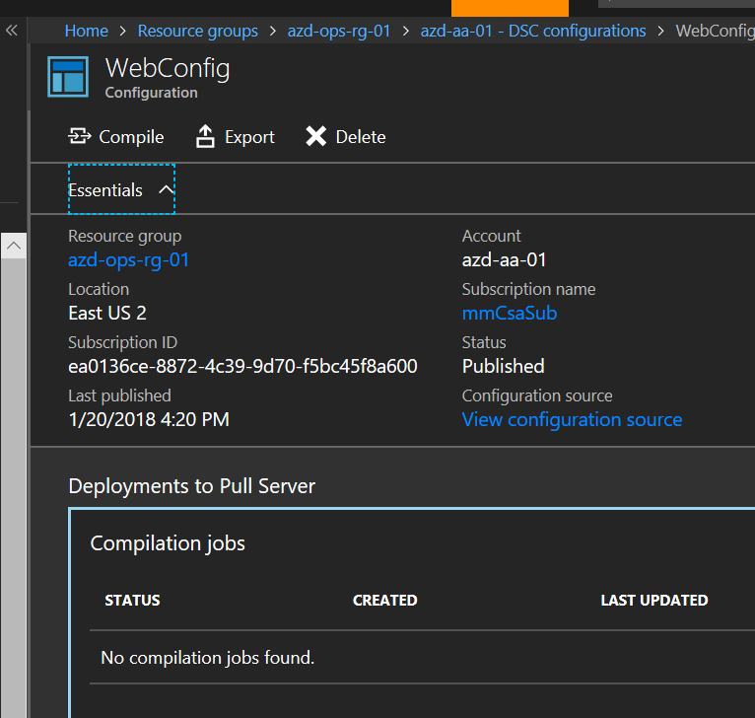  
  
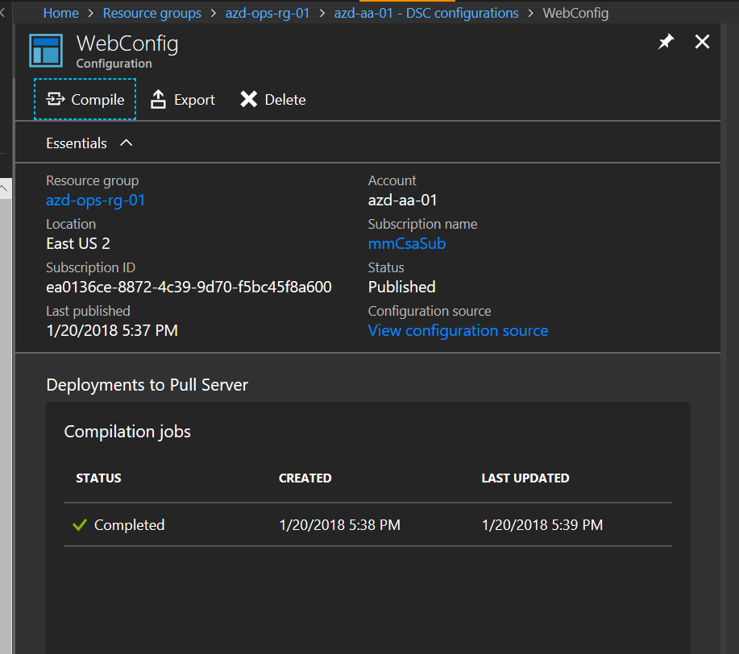

# Step 8 – Deploy Azure VNET with 3 subnets from ARM templates

## Overview

We will be deploying a simple Azure Virtual Network (VNET) configuration with 3 subnets. The deployment will be done from ARM template with a parameters file. Because we don’t have any requirements on unique names or other parameters that need to be changed, we can use the default values in the parameters file.

## Detailed Steps

1. Set a variable for $vnetResourceGroup with whatever name you want to give it and deploy a new resource group using:  
     
   $vnetresourceGroup = "azd-vnet-rg-01"

New-AzureRmResourceGroup -Name $vnetResourceGroup -Location $location   
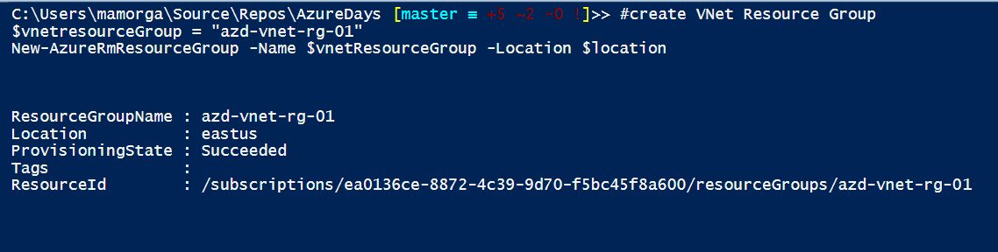

1. Deploy the VNET from template. Change the ‘$vnetParameterPath’ variable to your local path and run:  
     
   #Deploy VNET from template

$vnetTemplatePath = "$artifactsLocation/simplevnet.json"

$vnetparameterPath = "C:\Users\mamorga\Source\Repos\AzureDaysDraft\AzureDays\simplevnet.parameters.json"

New-AzureRmResourceGroupDeployment `

-Name azdVnetDeploy `

-ResourceGroupName $vnetresourceGroup `

-TemplateFile $vnetTemplatePath `

-TemplateParameterFile $vnetparameterPath `

-Mode Incremental `

-Verbose

The deployment will only take a few seconds to complete, you will receive output showing VNET info.  
  
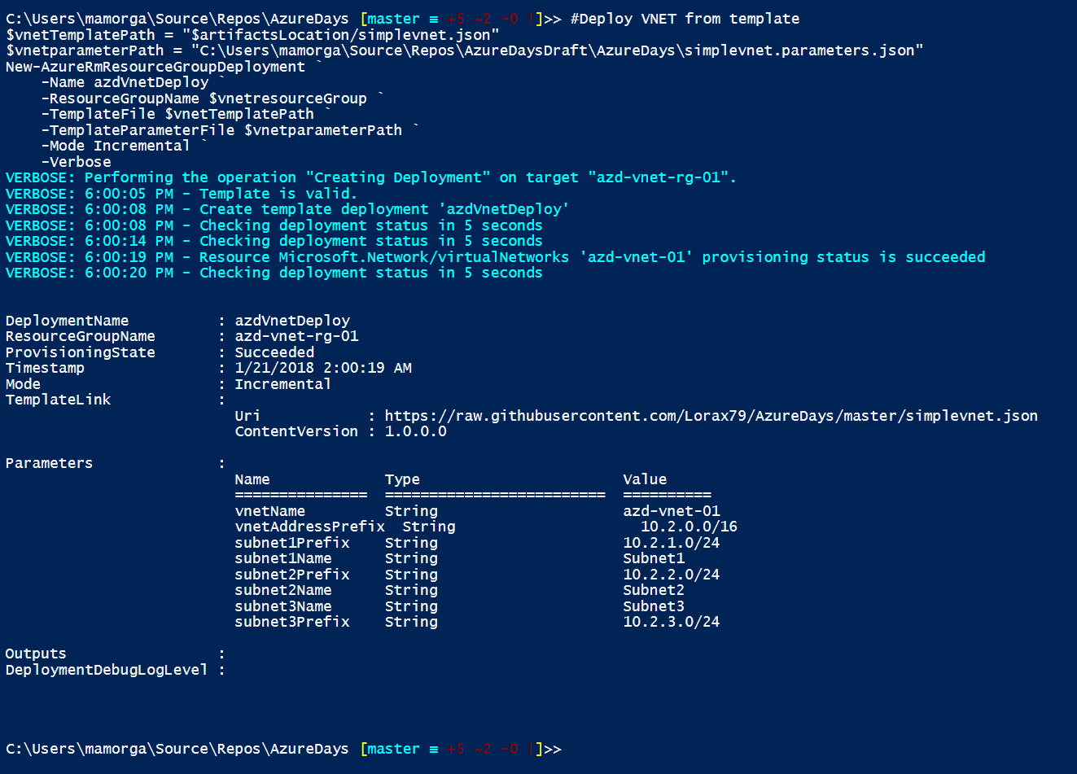

# Step 9 – Deploy Azure Load Balancer

## Overview

We will be deploying an Azure Load Balancer with a public IP address. We will be creating a new Public IP object, creating front and backend IP configurations, HTTP probes and load balancing rules for the load balancer. We will then update the load balancer config with a pair of NAT rules for RDP traffic for VMs behind the load balancer.

## Detailed Steps

1. Create a new Public IP object with a static address as variable $publicIp  
     
   $publicIP = New-AzureRmPublicIpAddress `

-ResourceGroupName $VNetresourceGroup `

-Location $location `

-AllocationMethod Static `

-Name myPublicIP

1. Check object by typing ‘$publicIp’ in command pane, copy the IpAddress to your notepad.

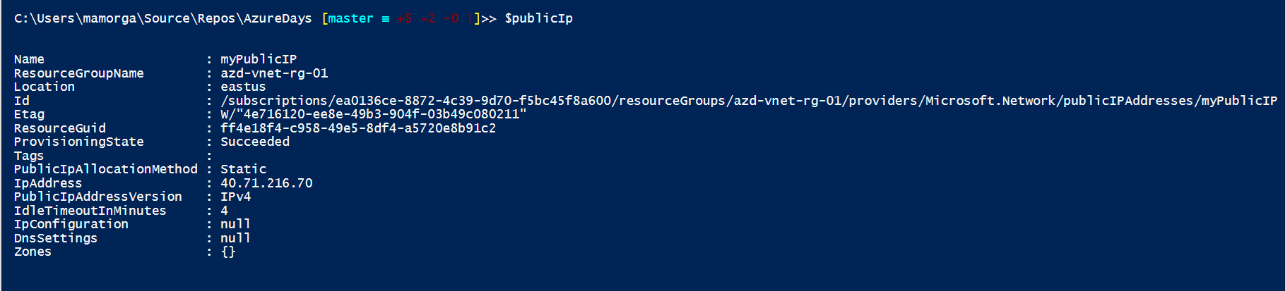

1. Create a Front-end IP configuration for the load balancer using the public IP just created:  
     
   $frontendIP = New-AzureRmLoadBalancerFrontendIpConfig `

-Name myFrontEndPool `

-PublicIpAddress $publicIP

1. Create a new empty backend pool for the load balancer:  
     
   $backendPool = New-AzureRmLoadBalancerBackendAddressPoolConfig -Name myBackEndPool
2. Create a new load balancer with the front/back end configs you have created:  
     
   $lb = New-AzureRmLoadBalancer `

-ResourceGroupName $VNetresourceGroup `

-Name azd-lb-01 `

-Location $location `

-FrontendIpConfiguration $frontendIP `

-BackendAddressPool $backendPool

1. Check the basic load balancer config by typing ‘$lb’ in command pane. Note the lack of rules, probes, NAT rules:

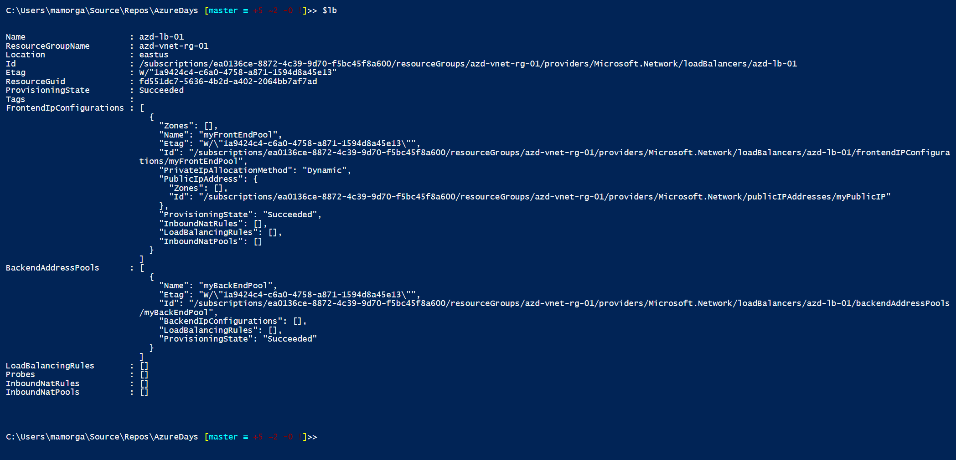

1. Create an HTTP probe for the load balancer. You will get an updated LB config back as response.   
     
   Add-AzureRmLoadBalancerProbeConfig `

-Name HttpProbe `

-LoadBalancer $lb `

-Protocol tcp `

-Port 80 `

-IntervalInSeconds 15 `

-ProbeCount 2

Set-AzureRmLoadBalancer -LoadBalancer $lb

$probe = Get-AzureRmLoadBalancerProbeConfig -LoadBalancer $lb -Name HttpProbe

1. Add a load balancer rule for HTTP, you’ll get an updated config response again.   
     
   Add-AzureRmLoadBalancerRuleConfig `

-Name HttpRule `

-LoadBalancer $lb `

-FrontendIpConfiguration $lb.FrontendIpConfigurations[0] `

-BackendAddressPool $lb.BackendAddressPools[0] `

-Protocol Tcp `

-FrontendPort 80 `

-BackendPort 80 `

-Probe $probe

1. Set the updated load balancer config, you will again get the updated config output.   
     
   Set-AzureRmLoadBalancer -LoadBalancer $lb

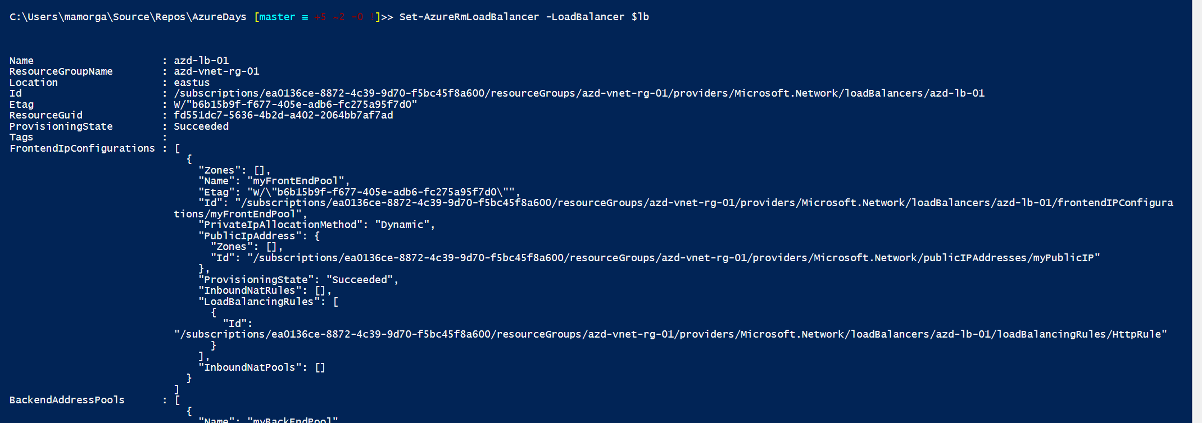

1. Configure 2 NAT rules to map inbound RDP traffic on ports 3341/3342 to port 3389 to backend pool.   
     
   $lb | Add-AzureRmLoadBalancerInboundNatRuleConfig `

-Name RDP1 `

-FrontendIpConfiguration $lb.FrontendIpConfigurations[0] `

-Protocol TCP `

-FrontendPort 3441 `

-BackendPort 3389  
  
$lb | Add-AzureRmLoadBalancerInboundNatRuleConfig `

-Name RDP2 `

-FrontendIpConfiguration $lb.FrontendIpConfigurations[0] `

-Protocol TCP `

-FrontendPort 3442 `

-BackendPort 3389

1. Set the load balancer config again to apply the updated NAT rules. We will attach VM network interfaces to the backend pool after deploying VMs.  
     
   Set-AzureRmLoadBalancer -LoadBalancer $lb

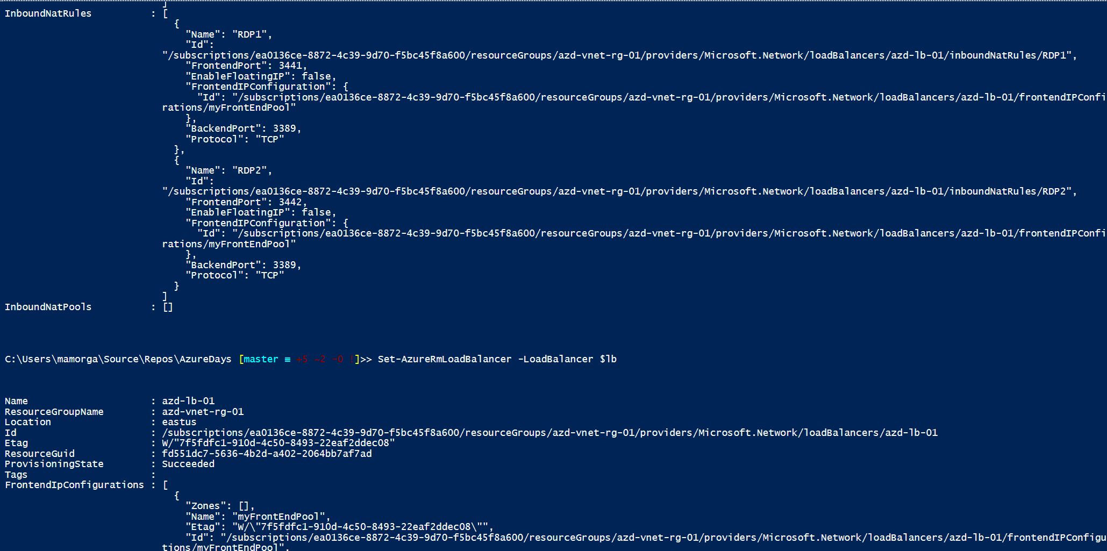

# Step 10 – Deploy and configure Azure Virtual Machines

## Overview

We will be running a deployment script which will deploy from 1 – N identical VMs from an ARM template. The VMs are deployed into the ‘app’ subnet in your VNET (subnet 2) and are striped across update and fault domains in an Availability Set. After deploying the base VMs the template will add extensions to install/configure both the OMS agent (MMA extension) as well as DSC. The VMs will then pull their DSC Local Config Manager config from a repo, and then connect to your Automation account to find and pull their Node Configuration (webconfig.web). When complete you should have 2 identical Windows Server 2016 w Containers hosts running an IIS website.

## Detailed Steps

1. Open ‘azdays-VmDeploy.ps1’ in Powershell ISE. We will be running directly from the ISE, however the same code should run called directly from PS, as an Automation runbook, or however as long as the required parameters are passed.   
     
   To run, press the ‘Run Script’ button or hit F5 from ISE

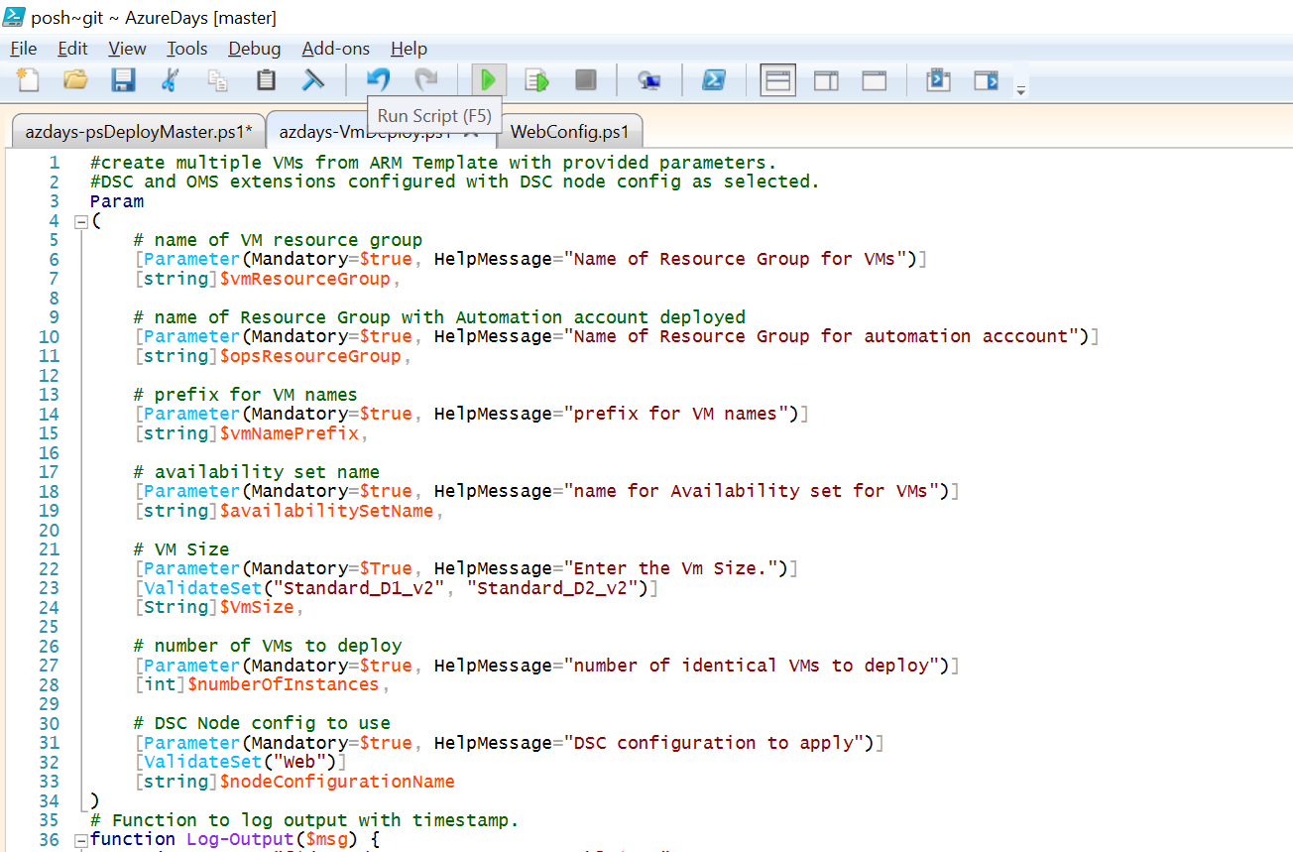

1. You will be prompted to enter parameters when launching the script:  
     
   **vmResourceGroup** – enter a name for a new VM resource group.  
   **opsResourceGroup** – enter the name of the resource group you deployed OMS, Automation into.   
   **vmNamePrefix** – enter a naming prefix for your VMs – will append a digit based on VM # to the end.   
   **availabilitySetName** – enter a name for a new Availability Set to create your VMs in.   
   **vmSize** – please use ‘Standard_D2_v2’ for VM size.  
   **numberOfInstances** – please use ‘2’ to create 2 identical VMs.  
   **nodeConfigurationName** – please use ‘Web’ to deploy correct DSC configuration for web server.

x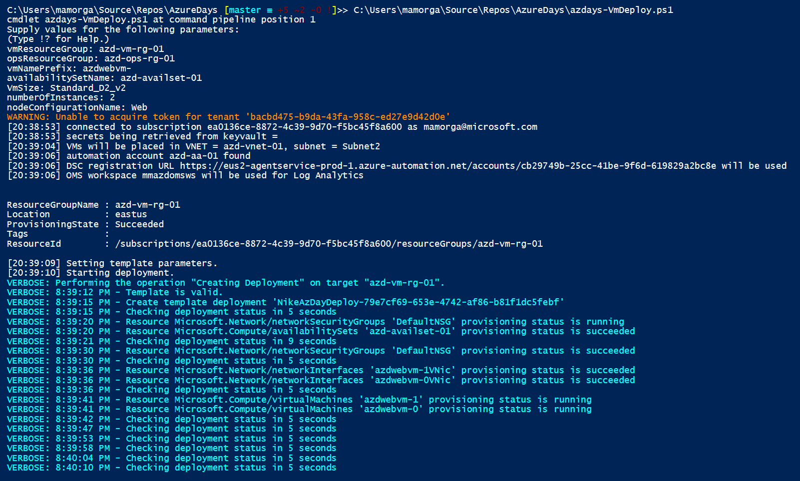

1. You will see verbose logging from the deployment while running. The VM deployment can take up to about 20 minutes to complete as the DSC configuration has a 15 minute pull interval between configurations. Once you reach the virtualMachine provisioning around 1 minute in without errors, you can move to the next step while the deployment finishes.

# Step 11 – Deploy Azure Container Registry for container images

## Overview

We will be creating Docker container images from our Windows servers after they have been configured. While the deployment script runs, we will create an Azure Container Registry to be able to store Docker images.

## Detailed Steps

1. Create a new Container Registry in the Ops resource group, Basic SKU with -EnableAdminUser flag so we can retrieve credentials later. Change the value for -Name to whatever unique alphanumeric name you wish.  
     
   $registry = New-AzureRmContainerRegistry -Name "azdayscontreg" -ResourceGroupName $OpsResourceGroup -Sku Basic -EnableAdminUser
2. Retrieve the registry credential & copy username + password to notepad for later:  
   .   
   $dockerCredential = Get-AzureRmContainerRegistryCredential -ResourceGroupName $OpsResourceGroup -Name $registry.Name   
     
   $dockerCredential

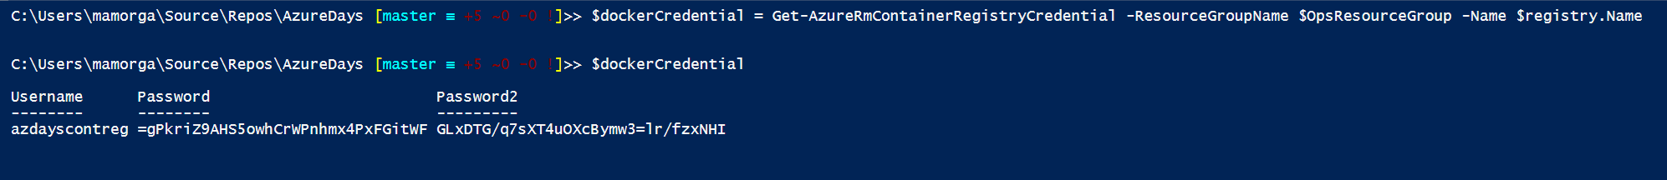

1. Once you have copied the user/password, we will create a secure credential object we can use to redeploy images from the Container Registry with in a later step.   
     
   $dockerSecurePass = ($dockerCredential.Password | ConvertTo-SecureString -AsPlainText -Force)

$dockerCredential = New-Object System.Management.Automation.PSCredential ($dockerCredential.Username, $dockerSecurePass)

# Step 12 – Validate VM deployments and attach to load balancer backend.

## Overview

When the VM deployment has completed, review the resources and configuration status for the VMs.

## Detailed Steps

1. Browse to your VM resource group and review the resources you created. You should see 2 Virtual Machines, 2 NICs, 4 disks, 1 Network Security Group, and 1 Availability Set.

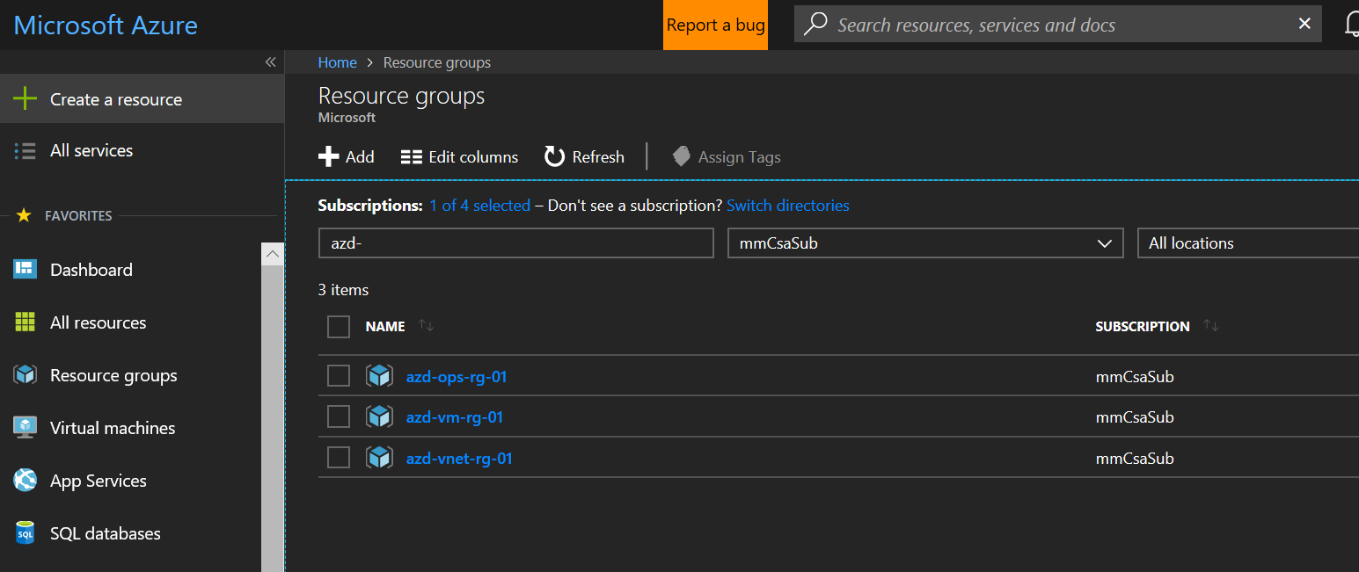  
  
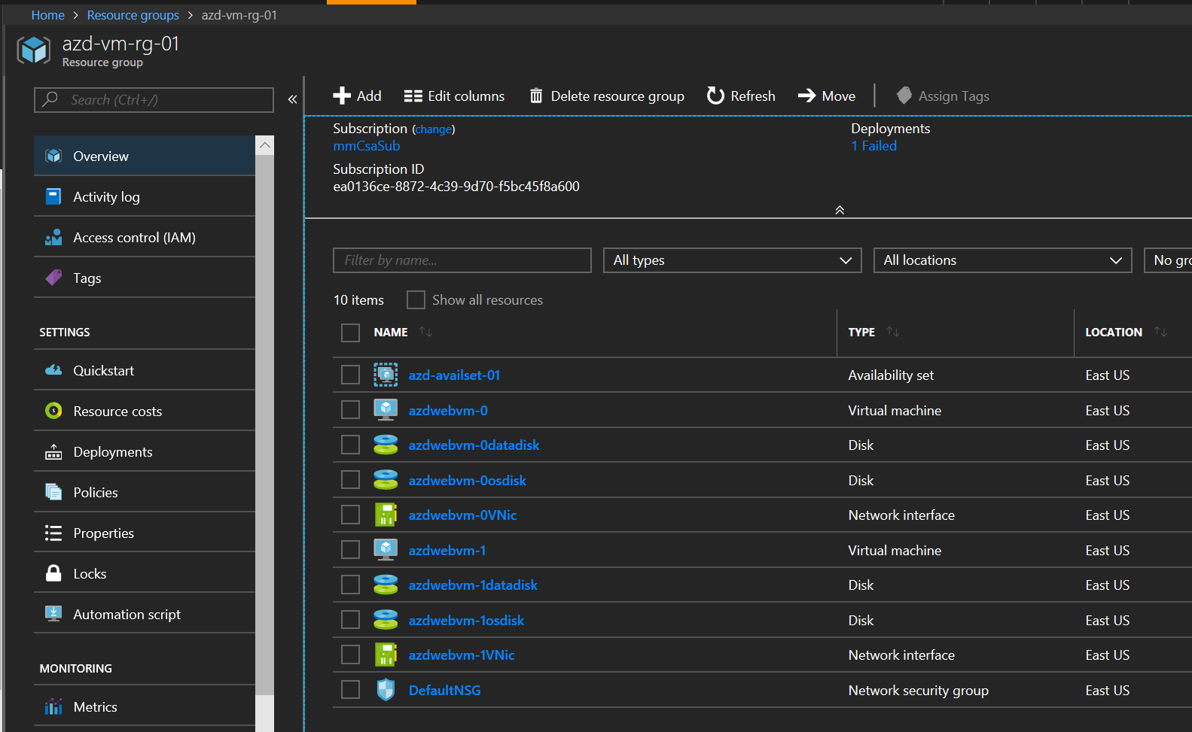

1. From the PS command pane, run the following to check compliance of the DSC config, both nodes should show ‘Compliant’.   
     
   Get-AzureRmAutomationDscNode -AutomationAccountName $autoAccountName -ResourceGroupName $OpsResourceGroup

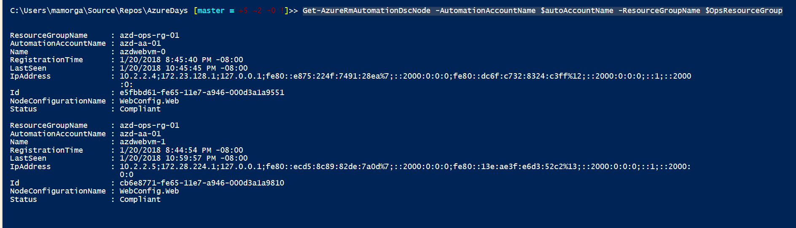

1. The last step in configuring the Virtual Machines will be to attach them to the load balancer backend pool. We will do so by retrieving the VM objects into an array using Get-AzureRmVm, parsing each VM’s NIC info and getting it’s NIC resource object, then applying the load balancer’s backend pool & NAT rules to each NIC’s IP configuration. You will see the NAT rules applied in the output.  
     
   $vms = Get-AzureRmVM -ResourceGroupName $vmResourceGroup

$lb = Get-AzureRmLoadBalancer -Name azd-lb-01 -ResourceGroupName $vnetresourceGroup

$vmCount = 0

foreach ($vm in $vms)

{

$nicId = $vm.NetworkProfile.NetworkInterfaces.id

$nicName = $nicId.split('/')[8]

$nic = get-azureRMNetworkInterface `  
 -Name $nicName `  
 -ResourceGroupName $vmResourceGroup

$nic.IpConfigurations[0].LoadBalancerBackendAddressPools=$lb.BackendAddressPools[$vmCount]

$nic.IpConfigurations[0].LoadBalancerInboundNatRules=$lb.InboundNatRules[$vmCount]

Set-AzureRmNetworkInterface -NetworkInterface $nic

$vmCount++

}

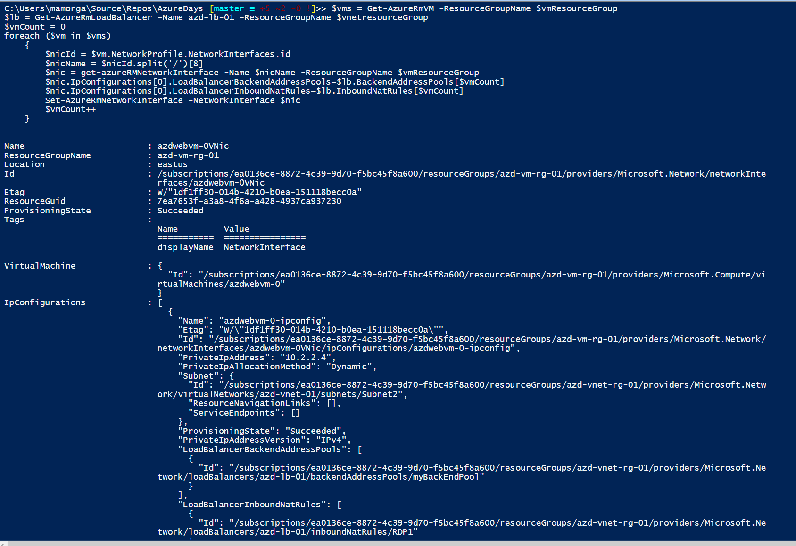

1. When complete you should be able to RDP to your VMs using the ***load balancer*** public IP you saved earlier on port 3441 (VM-0) or 3442 (VM-1).

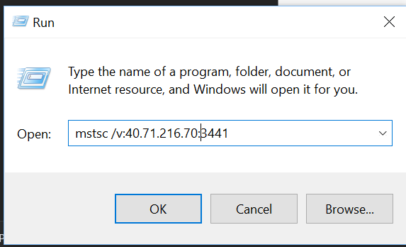

1. At the credentials prompt, select ‘more choices’ -> ‘Use a different account’. Login using the local admin credentials you created earlier, adding ‘VMNAME\’ for the domain.

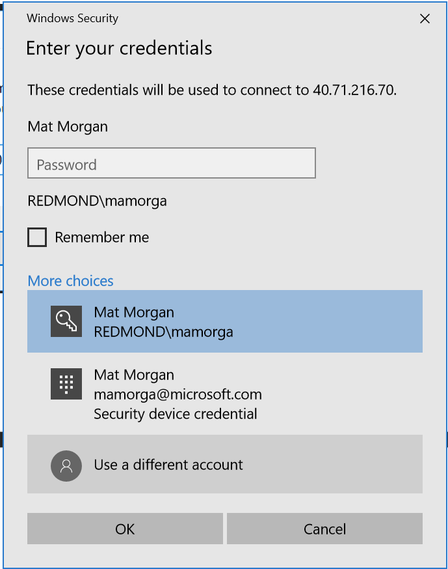

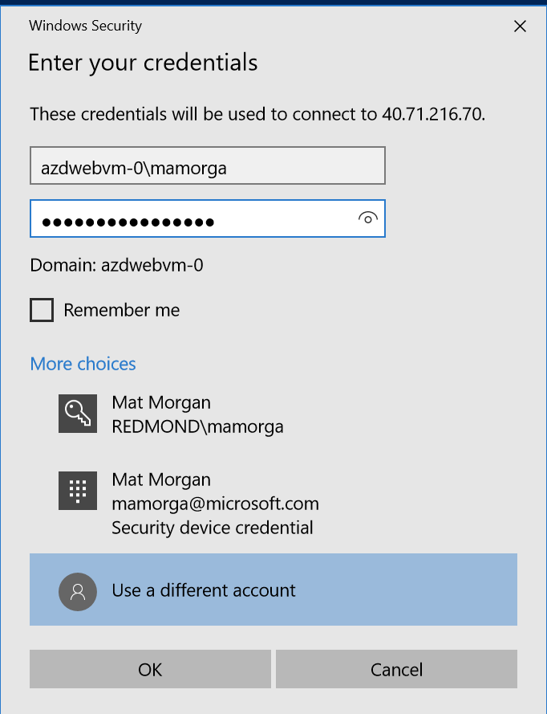

1. You should also be able to reach the website at http://<load-balancer-ip> from your machine.  
   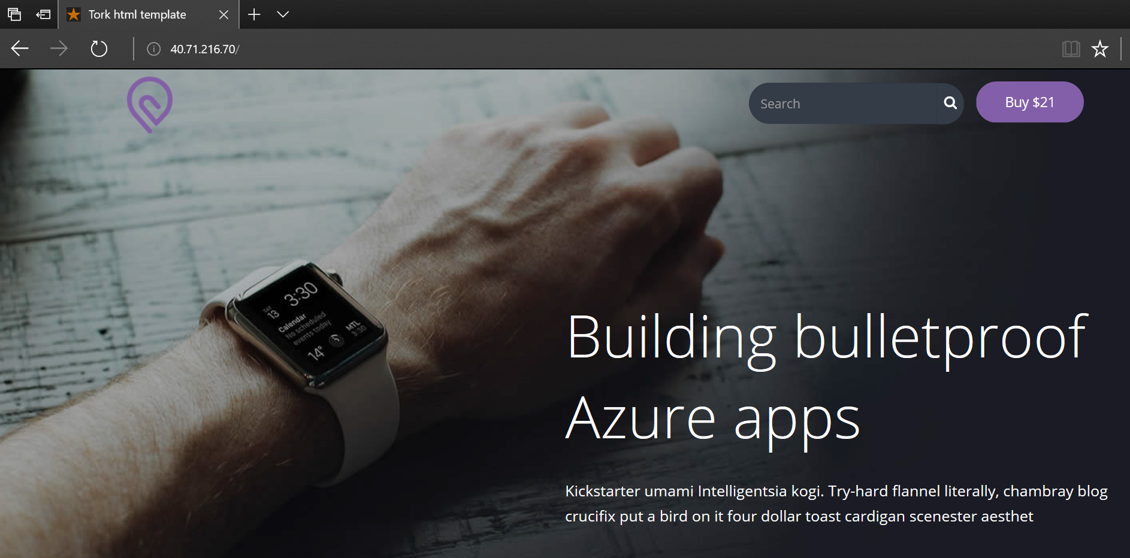

# Step 13 – Create Docker container from website and push to Azure Container Registry.

## Overview

Inception! For this step we will take advantage of Windows Containers in Server 2016 and build a Server Core + IIS container running our site from inside our VM. We will then push the container image to our Azure Container Registry.

## Detailed Steps

1. From an RDP session you either of your VMs, open a Powershell window.

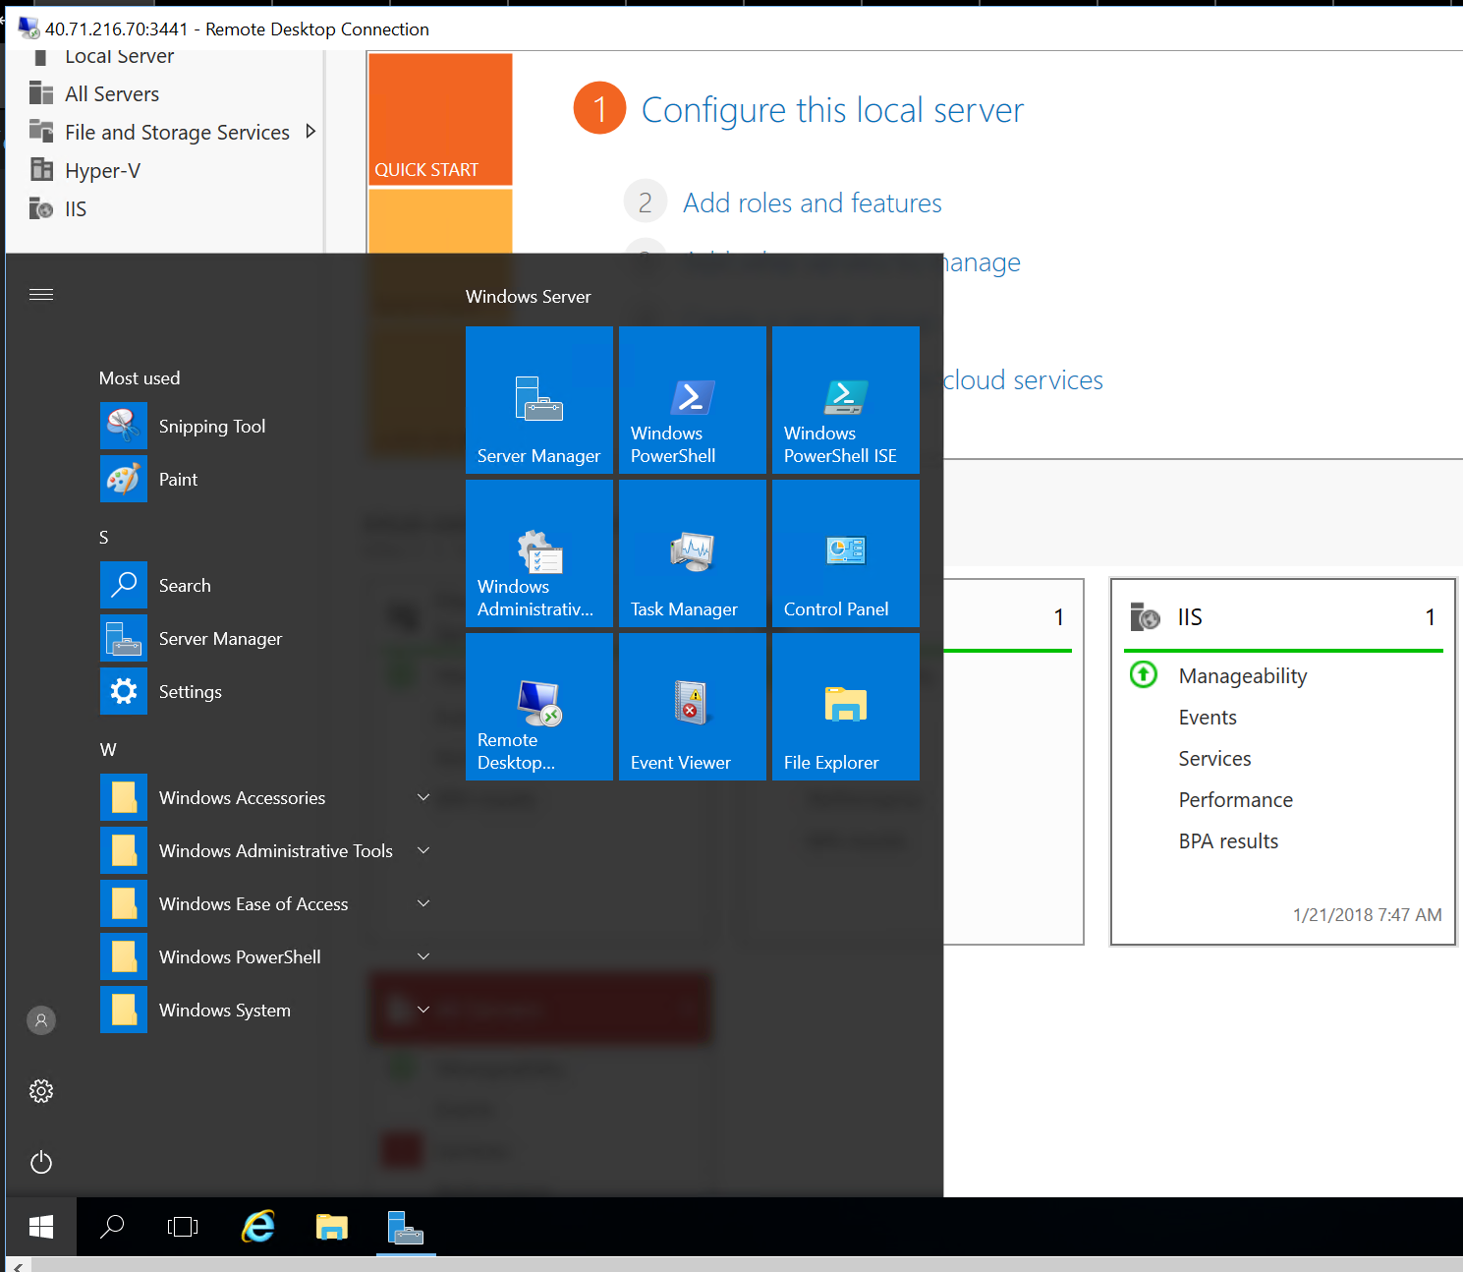

1. Create a new directory called ‘docker’ in your profile, cd to it.

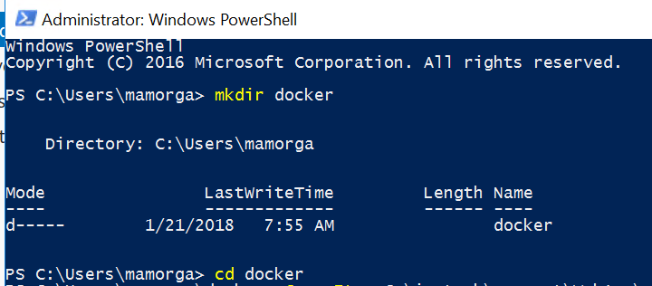

1. Copy the contents if the IIS website at C:\inetpub\wwwroot\WebApp\website into your docker directory.

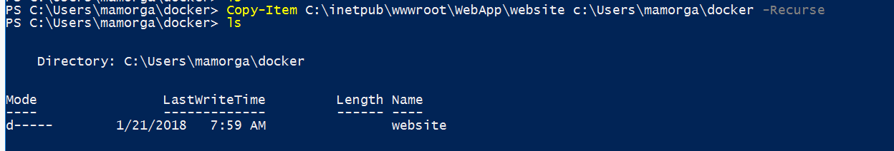

1. From Powershell, type ‘docker pull Microsoft/iis’ to pull the Server Core + IIS container from Docker Hub. It will take a few minutes to pull & extract.

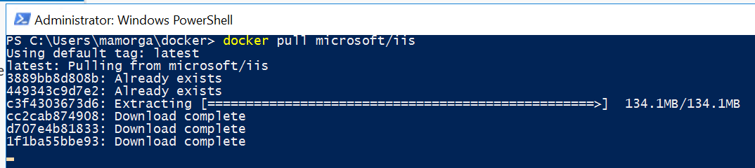

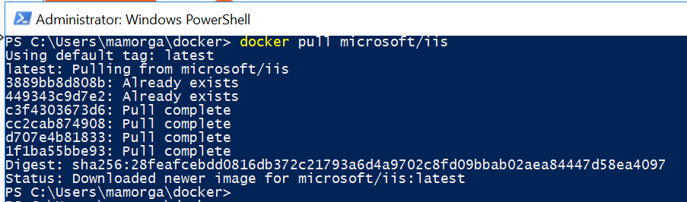

1. Type ‘notepad Dockerfile’ to create a new text file. Either copy/paste or enter the text as shown to create a Dockerfile that uses PS to configure the IIS site in the container, then adds the content from the docker\website directory to the container image. Note the first line designates **`** as the escape character instead of default **\** to avoid issues with Windows file paths. When complete, ‘Save As’ without any file extension with name as “Dockerfile” **include quotations**

# escape=`

FROM microsoft/iis

RUN mkdir C:\site

RUN powershell -NoProfile -Command `

Import-module IISAdministration; `

New-IISSite -Name "Site" -PhysicalPath C:\site -BindingInformation "*:8000:"

EXPOSE 8000

ADD \website /site

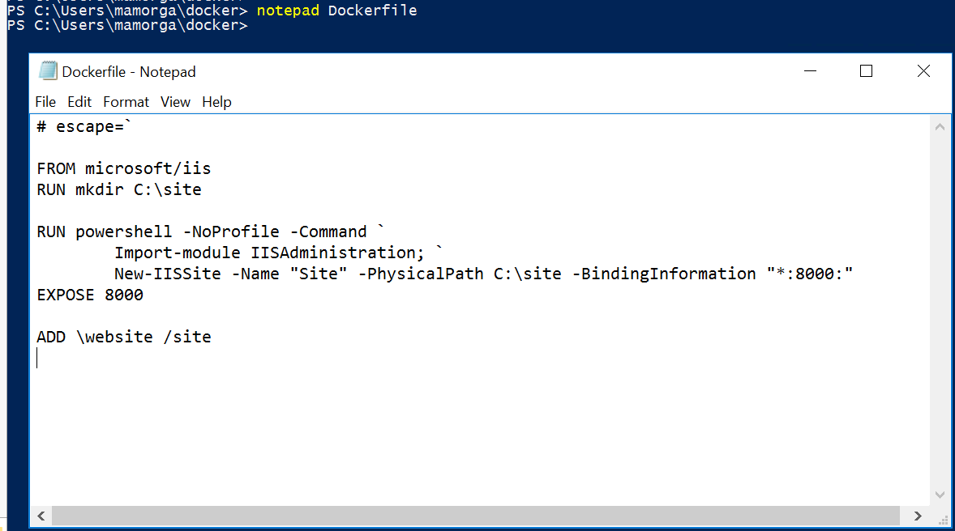

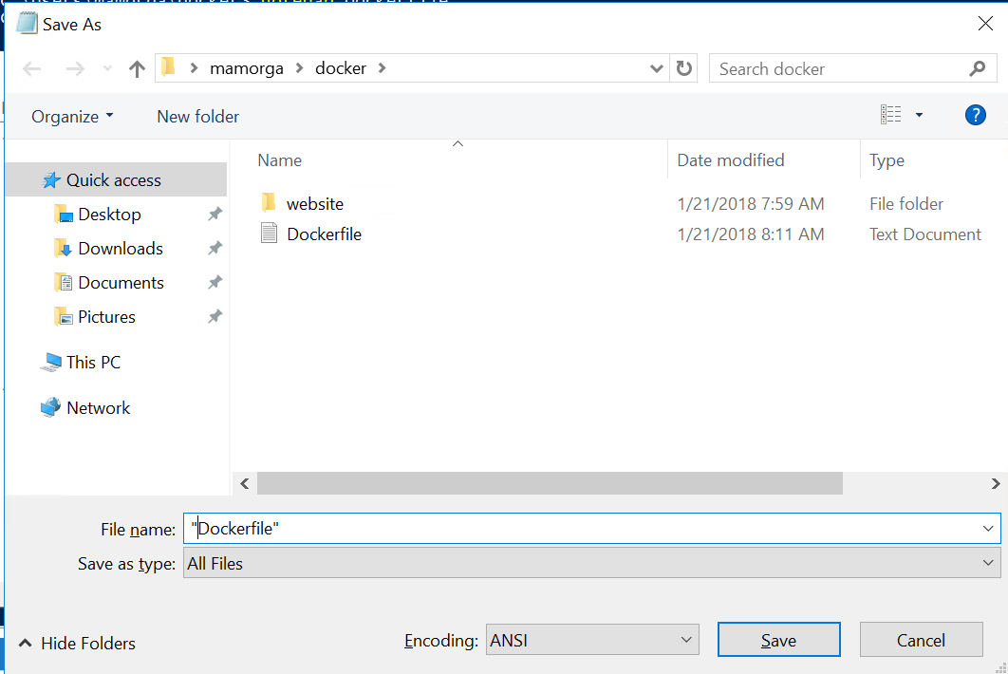

1. Type ‘**docker build -t iis-site .**’ (including period) to build the image from Dockerfile.

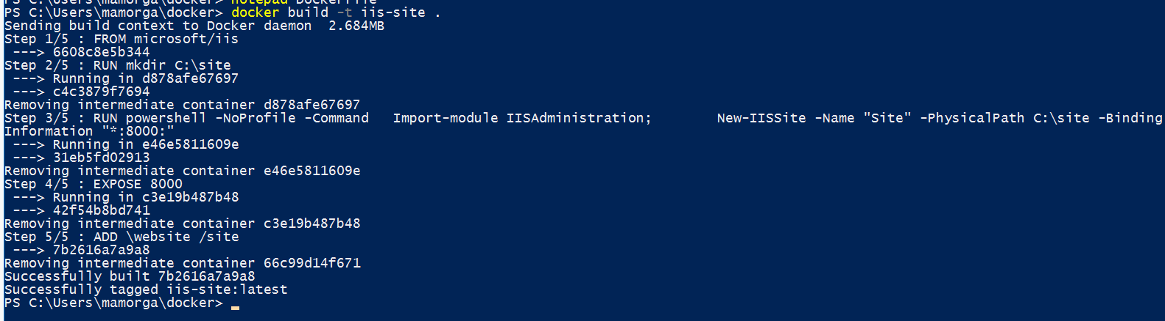

1. Type ‘**docker image ls**’ to view your image

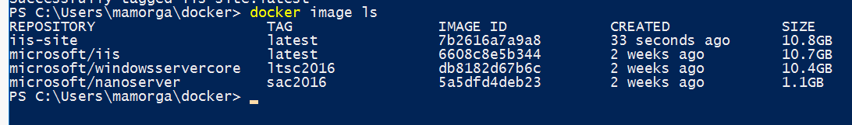

1. Type ‘**docker run -d -p 8000:8000 --name azdays-site iis-site**’ to run the container with port 8000 exposed. Type ‘docker ps -a’ to see the container state.

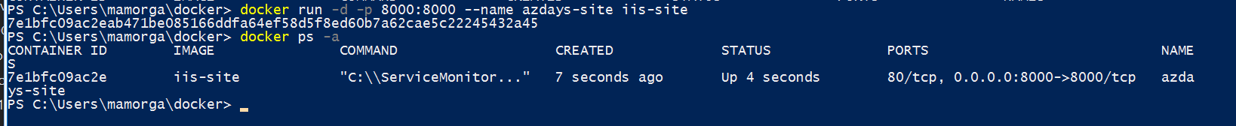

1. Type ‘**docker inspect -f "{{ .NetworkSettings.Networks.nat.IPAddress }}" azdays-site**’ to retrieve the IP address exposed for your container.



1. Open Internet Explorer from inside your RDP session. Accept the security prompt and browse to ‘**http://<your-container-ip>:8000**’ . You’ll have to click ‘Add’ 2x to approve the security zone prompt, then should see your site.

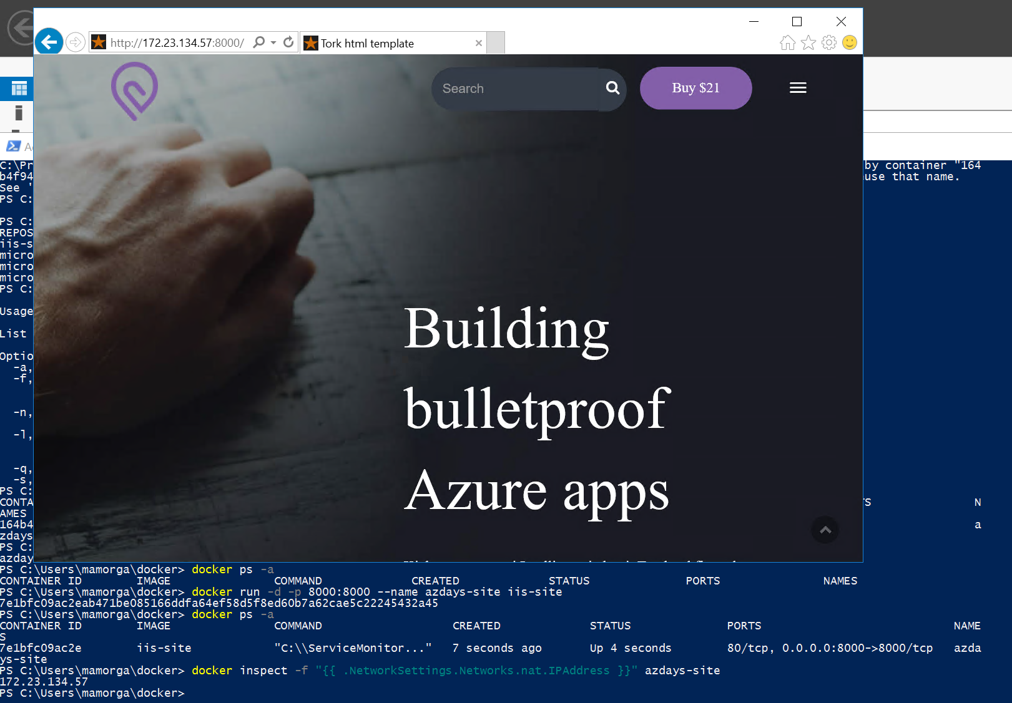

1. Find the Username and Password for the Azure Container Registry you saved earlier. The username will be the same as your ACR name.
2. Type ‘**docker tag iis-site <your-acr-username>.azurecr.io/iis-site:v1**’ to tab the image to push to the Registry.
3. Type ‘**docker login <your-acr-username>.azurecr.io -u <your-acr-username> -p <your-acr-password>**’ to login to ACR.
4. Type ‘**docker push azdayscontreg.azurecr.io/iis-site:v1**’ to push your image to the Registry.

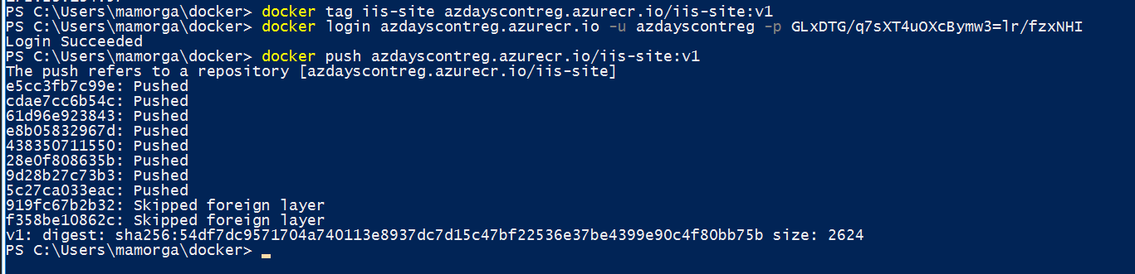

# Step 14 – Create an Azure Container Instance from image in Registry.

## Overview

Now just for fun, we will take our container image and redeploy it as an Azure Container Instance. Container Instances provide a fast easy way to deploy images in a PaaS service with no infrastructure for development.

## Detailed Steps

1. Run the following to create a new Container Group in the VM resource group using the image we just pushed. We will expose port 8000 on a public IP and use the secure credential object we created earlier to connect to the Registry.   
     
   $aci = New-AzureRmContainerGroup `

-ResourceGroupName $vmResourceGroup `

-Name azd-site `

-Image azdayscontreg.azurecr.io/iis-site:v1 `

-OsType Windows `

-IpAddressType Public `

-Port 8000 `

-RegistryCredential $dockerCredential

1. Type ‘$aci’ to check status after deploying. In a couple of minutes, you should see status as ‘Running’. Note the IP address shown.

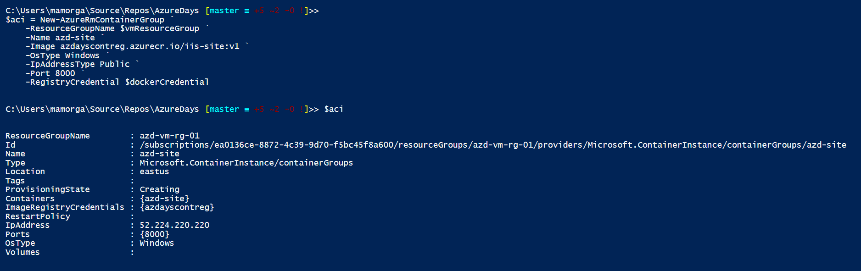

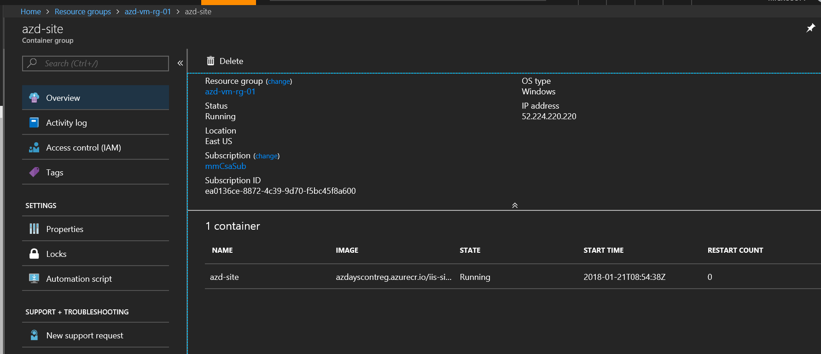

1. Try to connect to your Container Instance from a browser at ‘http://<aci-ip-address>:8000’

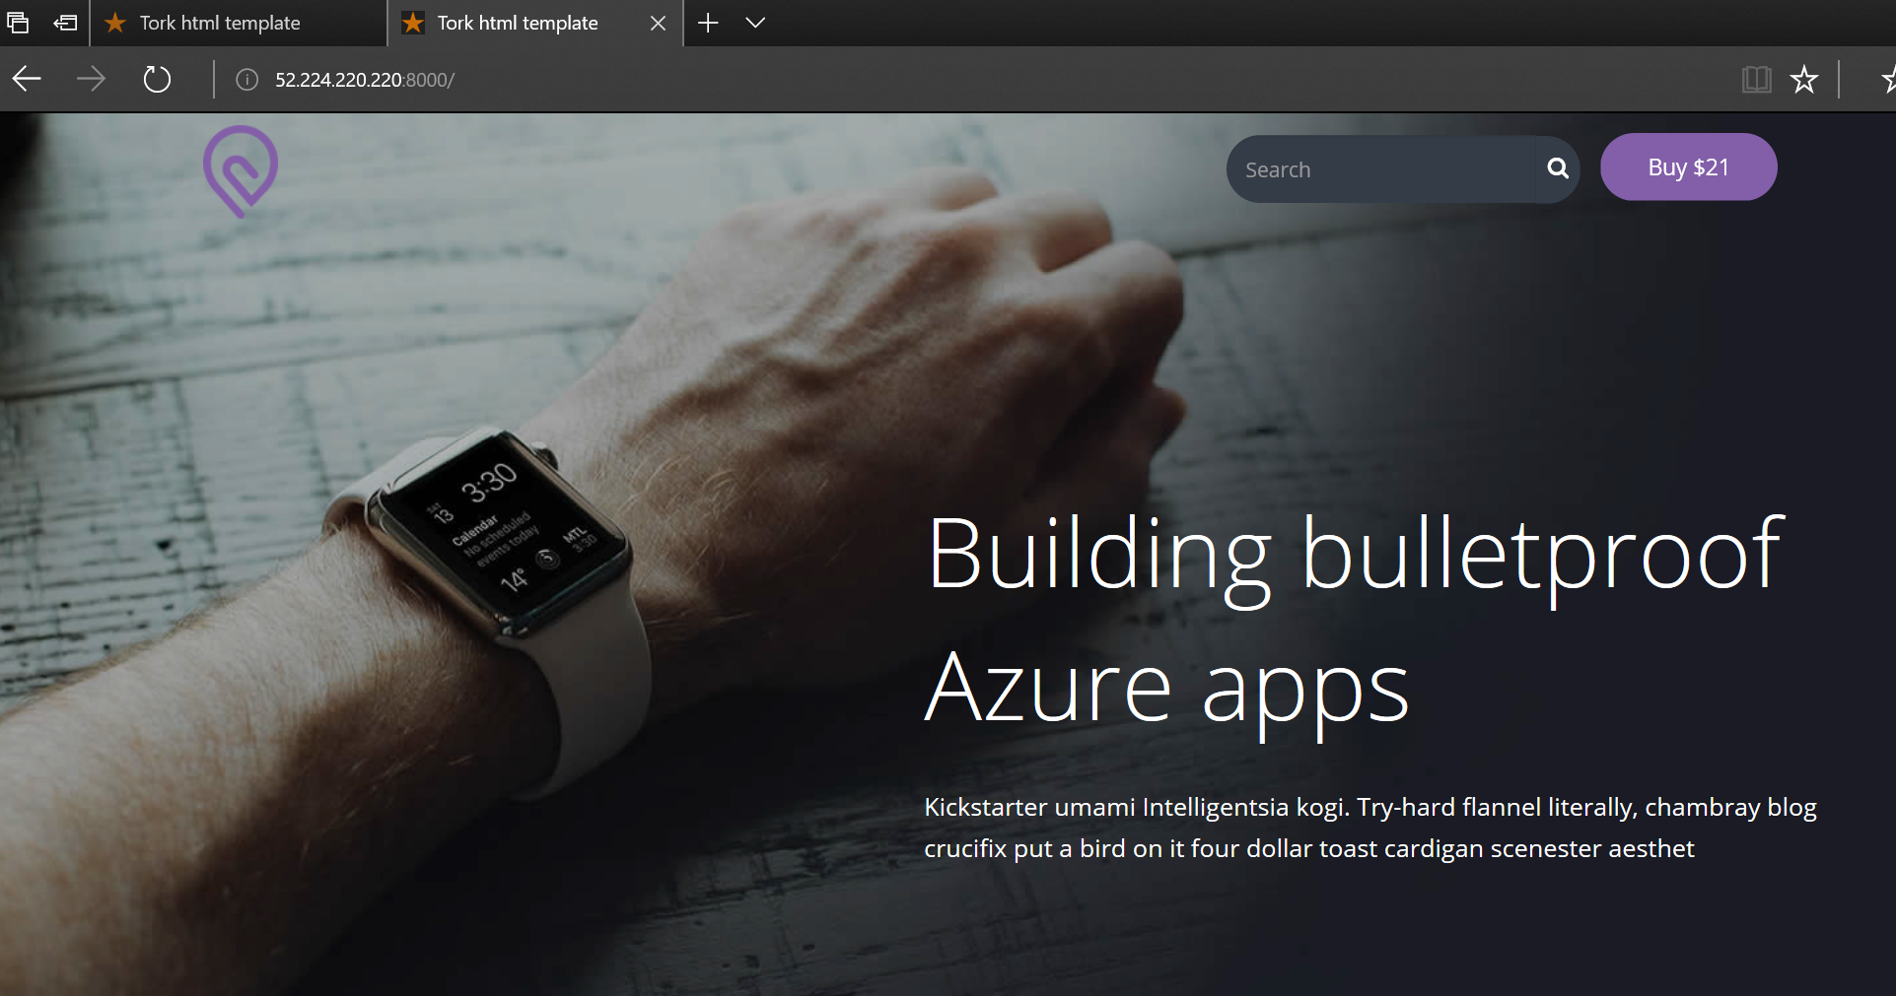

# Step 15 – Create an operations dashboard with Azure Monitor and Log Analytics.

## Overview

For this step we will use both the Azure Monitor service and Log Analytics queries to build and publish a shared dashboard showing VM performance and log data.

## Detailed Steps

1. In the Azure Portal, click the ‘Microsoft Azure’ icon in the top-left to return to the default dashboard. From the default dashboard, click ‘+ New dashboard’ to create a new empty dashboard. Give your dashboard a name.

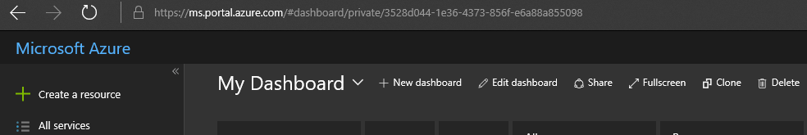

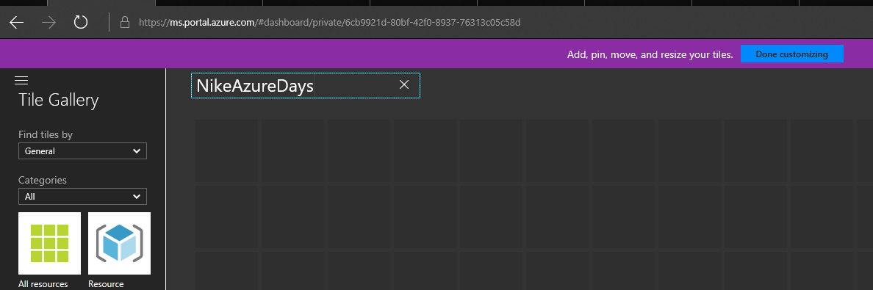

In the ‘Tile Gallery’ on the left, select ‘Find Tiles by’ to ‘Type’ and select ‘Virtual Machines’ from the Type dropdown. In the ‘Resources’ drop down that appears select one of your Virtual Machines. Click and drag the ‘CPU percentage’ tile onto the dashboard and it will appear as a 4x4 tile. Repeat for disk read/write if desired.

Select your other VM from the ‘Resources’ drop down and repeat.   
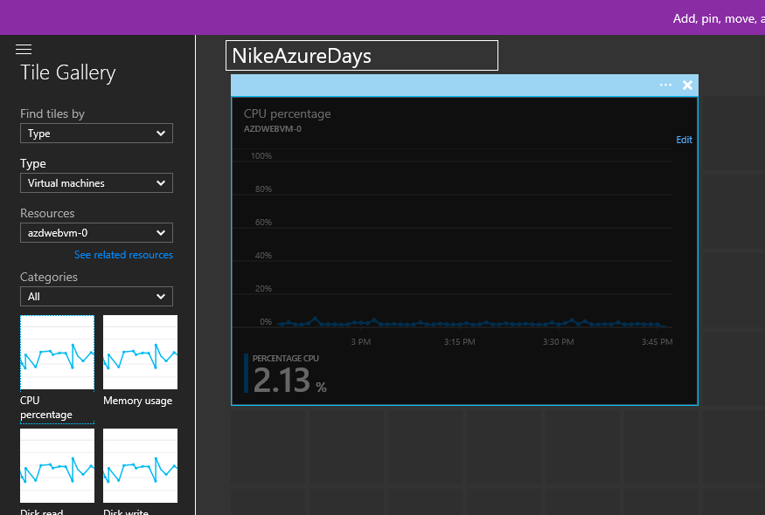

1. Once you have added some tiles to your dashboard, click ‘done customizing’ at the top.

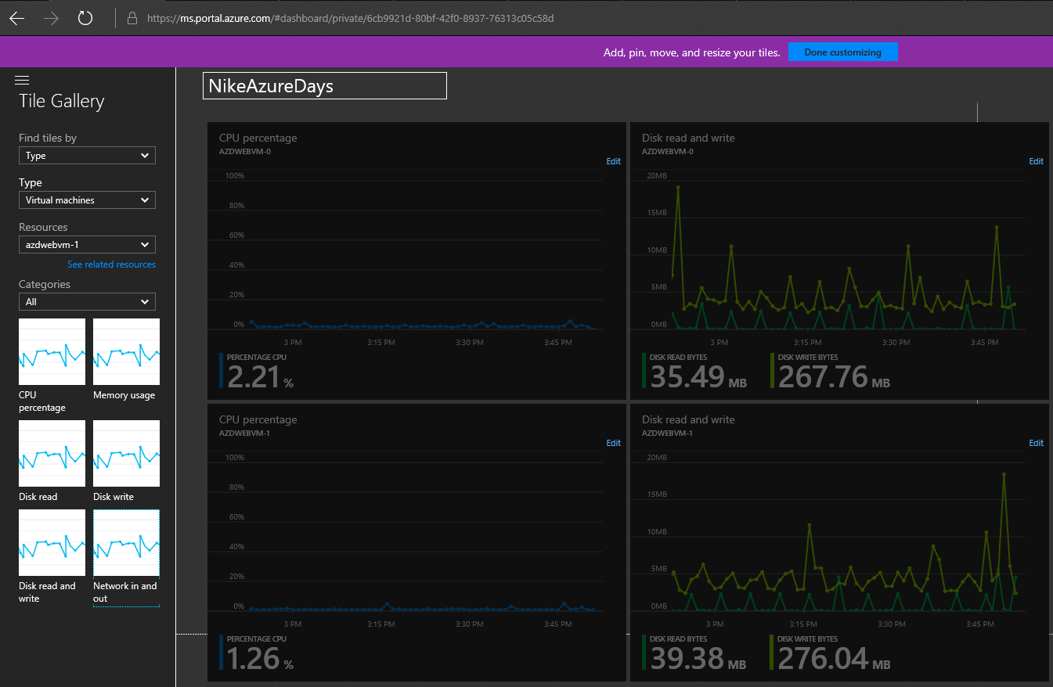

1. From the dashboard page, click ‘Share’ at the top, a sharing blade will open at the right. Uncheck the ‘Publish to the dashboards resource group’ option, and select your Operations resource group from the list and click ‘Publish’.

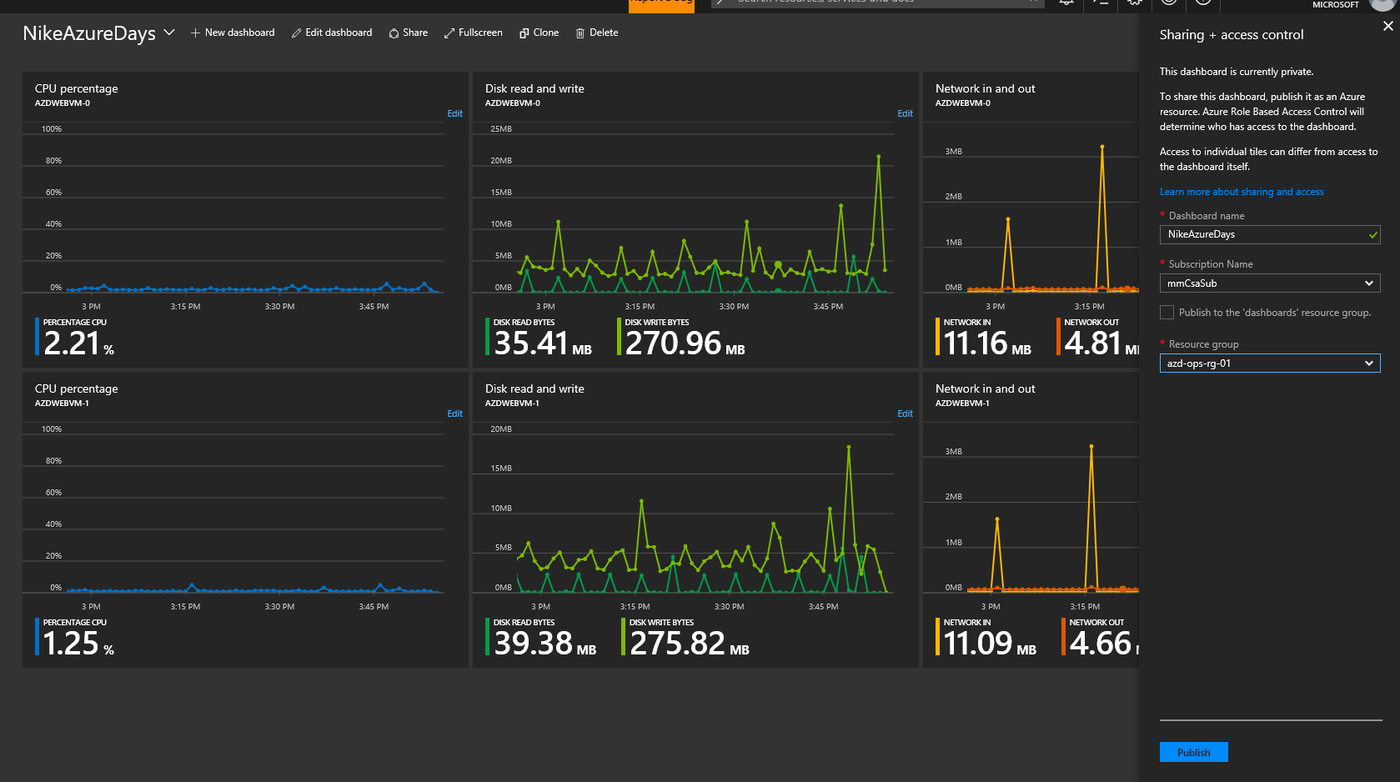

1. Browse to the Log Analytics workspace you created in your Ops resource group and select Log Search to pull up the Log Query page.

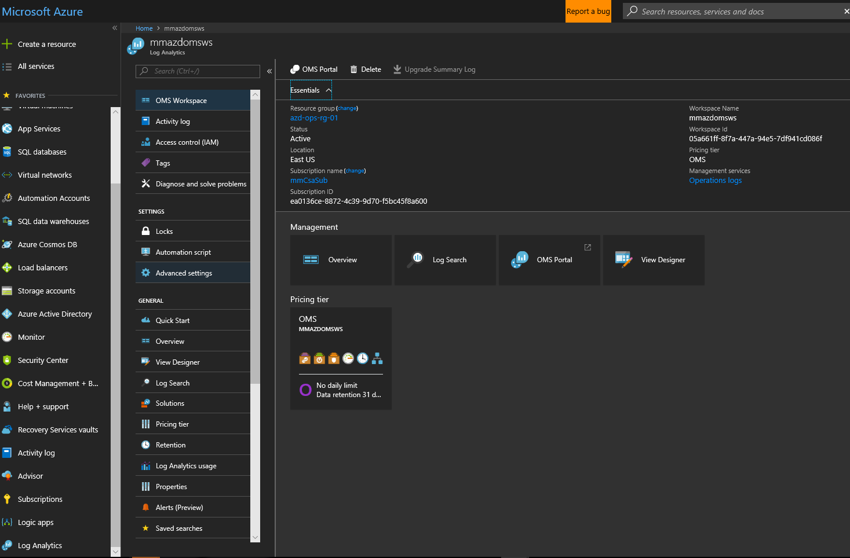

1. While we can run log queries directly from this page, for the purpose of providing a better look at the Log Analytics query functions & data we will use the ‘advanced analytics’ portal for the service. Click ‘Analytics’ at the top of the page to open the **portal.loganalytics.io** site in a new tab.

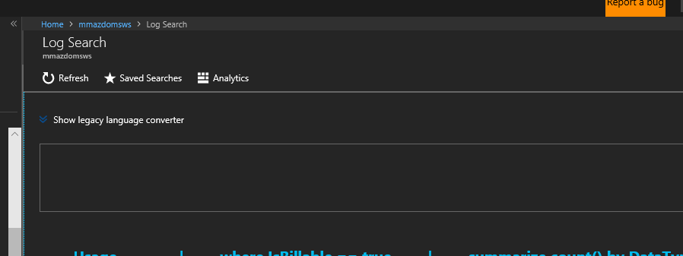

1. From the Log Analytics portal, click ‘+’ to open a new query tab

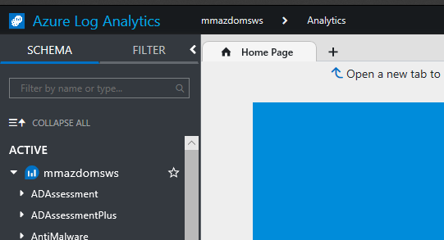

1. In the query window, type ‘Perf’ and hit the ‘Run’ button (or select query text and hit SHIFT + ENTER to run). This will pull all performance log data for your VMs for the time period chosen (default 24 hrs).

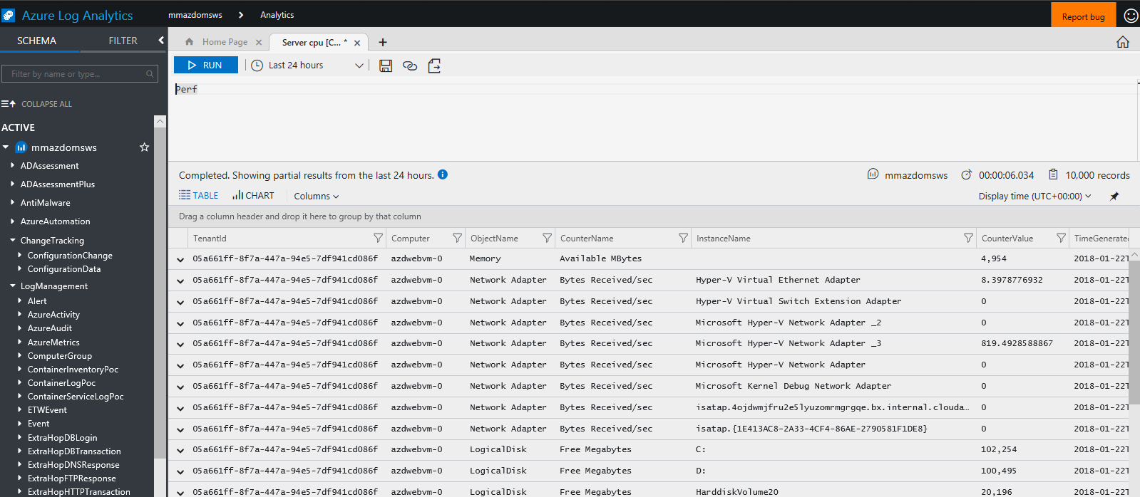

1. Click ‘+’ again to open another query tab. This time paste or type the query below to pull Perf CPU data for all VMs, summarized in 15 min intervals and plotted on a timechart. When you run it, you should get a chart like below.

//Servers CPU

Perf

| where CounterName == "% Processor Time" and ObjectName == "Processor" and InstanceName == "_Total"

| summarize AVGCPU = avg(CounterValue) by bin(TimeGenerated, 15m), Computer

| sort by TimeGenerated desc

| render timechart

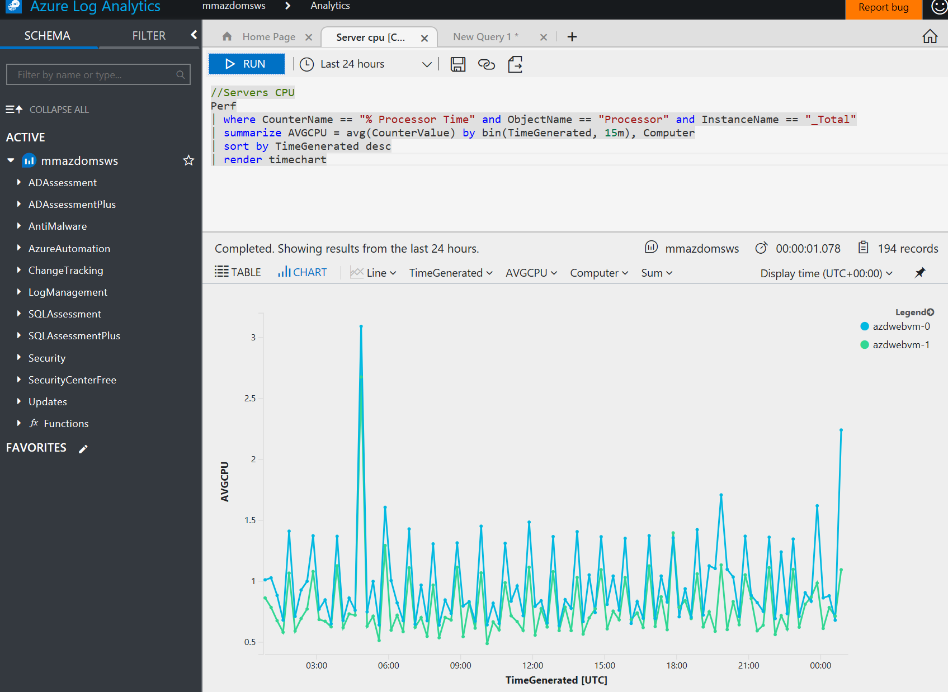

1. Click the ‘pin’ icon at the top-right of the chart to pin the graph to your published dashboard. You should now see this view added to the dashboard.   
   If you need to move the tile, click-hold and drag to edit and then resave/publish. Sometimes you need to take baby-steps when moving tiles.   
   You can click the ‘disk’ icon at the top to save your query into the workspace for later use.

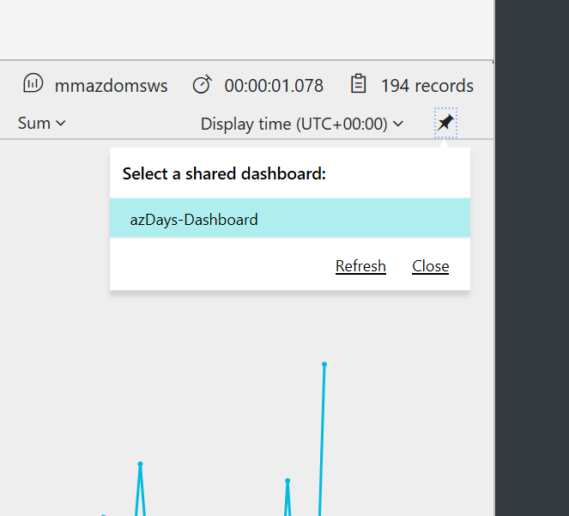

1. Repeat the above steps with these 3 queries to get memory utilization, IIS response time views, Error events, pin the outputs to your dashboard.

Perf

| where CounterName == "% Committed Bytes In Use" and ObjectName == "Memory"

| summarize AVGMEM = avg(CounterValue) by bin(TimeGenerated, 15m), Computer

| sort by TimeGenerated desc

| render timechart

W3CIISLog

| summarize ResponseInMS = avg(TimeTaken) by cIP

| render barchart

let vm1 = Heartbeat | where Computer == "azdwebvm-0";

let vm2 = Heartbeat | where Computer == "azdwebvm-1";

let combinedGroup= union vm1, vm2;

let projectedComputers = combinedGroup | summarize makeset(Computer);

Event

| where Computer in (projectedComputers)

| summarize count(EventLevelName) by Computer, EventLevelName

| render piechart

1. After you’ve pinned a couple of queries to your dashboard, return to the dashboard. To change the title of the tiles you just added, click the ‘…’ icon in top-right corner when hovering over the tile and select ‘Edit Title’. Change the title and subtitle and click ‘update. Then publish your changes again.   
   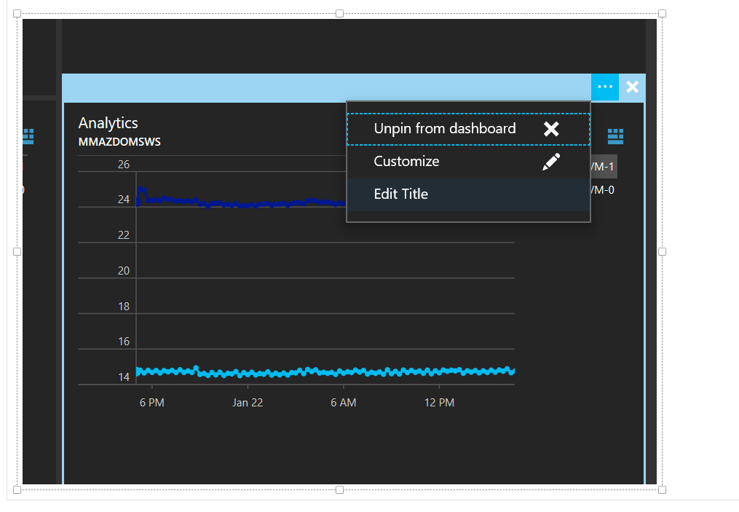
2. From any of the dashboard tiles you pinned from Log Analytics, click the blue ‘Analytics’ icon to return to the query & underlying data.

## Extra Credit

Visit the language query reference here: <https://docs.loganalytics.io/docs/Language-Reference>

Produce more queries and a make an even better dashboard!

# Step 16 – Clean up

## Overview

To clean up from the workshop, delete each of the 3 resource groups you created in reverse order: 1st VM resource group, 2nd VNET resource group, 3rd Ops resource group.

## Detailed Steps

Browse to each resource group landing blade. Click Delete and type the name of the resource group to confirm. You can delete all 3 without waiting for completion of the previous ones.